

Inverted Pendulum PID Demonstrator

Matthew Handley, Joseph Sedutto, Austin Cardosi, Kathryn Swineford

Southern New Hampshire University

Junior Engineering Design EG-310-20805 Spring 2023

April 19, 2023

## Table of Contents:

**Table of Contents: 2**

**Table of Tables: 3**

**Table of Figures: 3**

**Abstract: 5**

**Project Description 6**

Problem Statement 8

Summary of Concept of Operations 8

**System Requirements and Verification 11**

Functional and Performance System Requirements 11

Design, Interface, and Resource Requirements 12

**Verification 14**

**Conceptual Design 23**

Initial Research 24

**Detailed Design 29**

Overall System 29

Trade Studies 31

Mechanical System 33

Software System 36

Electrical System 40

Detailed Design 42

Health and Safety Features 43

**Fabrication and Integration 44**

**Comprehensive Performance Test 54**

**Schedule 57**

**Project Budget 58**

**Conclusions and Lessons Learned 59**

**References 63**

**Appendices 64**

Appendix A. Verification Report 64

## 

## Table of Tables:

Table 1.1 Functional and Performance System Requirements………………………………….11

Table 1.2 Design, Interface, and Resource System Requirements……………………………...12

Table 1.3 Motor Trade Study Matrix…………………………………………………………....31

Table 1.4 Frame Material Trade Study Matrix…………………………………………………..32

Table 1.5 Pendulum Trade Study Matrix………………………………………………………..32

Table 1.6 Project Schedule………………………………………………………………………57

Table 1.7 Project Budget………………………………………………………………………...59

## Table of Figures:

Figure 1.0 Rotary Inverted Pendulum……………………………………………………………23

Figure 1.1 Reaction Wheel Inverted Pendulum………………………………………………….24

Figure 1.2 System Operational Flow Chart……………………………………………………...25

Figure 1.3 Design Scale………………………………………………………………………….25

Figure 1.4 CAD Concept Design………………………………………………………………...26

Figure 1.5 Initial Sketches……………………………………………………………………….26

Figure 1.6 CAD Concept Design………………………………………………………………...27

Figure 1.7 Initial Drawing……………………………………………………………………….27

Figure 1.8 Initial sketch …………………………………………………………………………28

Figure 1.9 Full System Assembly………………………………………………………………..29

Figure 2.0 Operational Flow Chart……………………………………………………………....30

Figure 2.1 System Functional Block Diagram…………………………………………………...31

Figure 2.2 Subsystem Mechanical Design……………………………………………………….33

Figure 2.4 Carriage and Pendulum Components………………………………………………...33

Figure 2.5 Carriage and Pendulum Components………………………………………………...34

Figure 2.6 Carriage and Pendulum Components………………………………………………...34

Figure 2.7 Mechanical Subsystem Flow Diagram ……………………………………………....35

Figure 2.7.1 PID Balancing Control Algorithm………………………………………………….36

Figure 2.7.2 Difference Between P, PI, and PID Loop Infographic……………………………..37

Figure 2.7.3 TFT Screen Plotting and Constant Display………………………………………...37

Figure 2.7.4 Encoder Calibration………………………………………………………………...38

Figure 2.7.5 TFT Screen Plotting and Constant Display………………………………………...38

Figure 2.8 Software Subsystem Flow Diagram……………………………………………….....39

Figure 2.9 Subsystem Electrical Design…………………………………………………………40

Figure 3.0 Electrical subsystem Schematic……………………………………………………...40

Figure 3.0.1 Electrical subsystem Schematic……………………………………………………41

Figure 3.1 Electrical Subsystem Flow Diagram…………………………………………………41

Figure 3.2 Detailed Design………………………………………………………………………42

Figure 3.3 Assembled Detail Design…………………………………………………………….43

Figure 3.4 Electrical Component Testing………………………………………………………..44

Figure 3.5 Soldering stencil……………………………………………………………………...45

Figure 3.6 Circuit Board…………………………………………………………………………45

Figure 3.7 3D Printing…………………………………………………………………………...46

Figure 3.8 Cutting Steel Stock…………………………………………………………………...46

Figure 3.9 Steel Legs…………………………………………………………………………….47

Figure 4.0 TFT Screen…………………………………………………………………………...47

Figure 4.1 Using Angle Grinder…………………………………………………………………48

Figure 4.2 CNC Machining……………………………………………………………………...48

Figure 4.3 TIG Welding………………………………………………………………………….48

Figure 4.4 Wooden Frame………………………………………………………………………..49

Figure 4.5 Primed Wood…………………………………………………………………………49

Figure 4.6 Power Cable…………………………………………………………………………..50

Figure 4.7 3D Printing…………………………………………………………………………...50

Figure 4.8 Carriage Assembly…………………………………………………………………...51

Figure 4.9 Belt Tensioner………………………………………………………………………...51

Figure 5.0 Brass Endweight……………………………………………………………………...52

Figure 5.2 External Debugger……………………………………………………………………52

Figure 5.2 External Debugger……………………………………………………………………61

## 

## **Abstract:**

The pid demonstrator uses a control algorithm known as a pid loop to balance a pendulum in an inverted position through the use of a Nema 23 motor manipulating the pendulum’s pivot point along linear rails. The system will demonstrate to users the effect of manipulating the P, I, and D constants in this type of algorithm as the mechanical balancing behavior of the pendulum changes. Users also have a digital reference as the system’s changing balancing behavior is demonstrated to the user using a colored TFT screen. The system will be used as an educational tool for control system engineers in industry and students in high school or college.

## 

## **Project Description**

Team Pendulum 328 was tasked with creating a pid demonstrating machine. A pid algorithm is used to slow down a motor or actuator as it approaches a target position. As a result, the control algorithm is paramount for balancing tasks as any overshoot or uncontrolled manipulation will cause balance to be lost. Therefore, the pendulum team made a robot to balance a pendulum upside down. The pivot point of the pendulum is manipulated using a Nema 23 motor and a sprocket-and-belt-system to offset the falling motion of the pendulum. The pivot point is to slide along linear rods using linear bearings. The carriage manipulating this pivot point shall have an internal mechanism for holding the belt captive. The belt and sprocket subassembly will have an adjustable tensioning system for ease of use using an eccentric cam attached at the end of the sprocket and belt system opposite the Nema 23 motor. A motor encoder will be used to record the pendulum’s current position so the motor knows what actions must be taken to keep the pendulum balanced. The pendulum shall be made of carbon fiber tubing to reduce weight, and the end of the pendulum will have a brass end weight to increase the pendulum’s area moment of inertia - its resistance to changing its current state of motion.

The frame of the system shall be made of welded steel for stability, and all electronics will be housed in a ventilated wooden box at the bottom of the system. The system shall be powered from a standard 120V outlet from the wall using a power supply. A custom circuit board will use an Atmega328P microcontroller to manipulate the entire system. Limit switches will be built into the system to avoid the moving pivot point from colliding with the frame. An emergency stop will be built into the power supply to immediately cut power to the system in the case of an emergency. The system is meant to be both educational and a display piece. As a result, the system will have removable legs to raise its elevation and give it a more substantial profile. The legs will also lower the system’s center of gravity to prevent the system from falling over. The operating environment for the system will be the standard educational classroom or hallway.

The system will have four main operating modes. The first mode will be known as the spin-up mode in which it uses harmonic oscillations at a resonant frequency to increase its arcing length each time it swings back and forth. This concept is similar to how a child swings their legs at the right time on a swing to swing to a higher altitude. The next mode will be an autonomous mode in which the system will demonstrate what a proper balancing pid loop looks like for those using the system. The third mode is the user control mode. Three potentiometers will be nested in the control panel at the front of the system. The potentiometers have a varying resistance depending which position you turn them to. This range of resistance values can then be assigned a range of P, I, and D values in the code respectively. As the user spins the potentiometers, the constants in the balancing algorithm will change, and that change will be physically displayed to the user through the pendulum’s motion. To further demonstrate what is going on, a colored TFT screen will be integrated into the control panel that displays what is happening to the user. Three lines will be displayed on the screen. One line will remain flat in the center of the screen to display where a balanced state is located. The second line will show the user the pendulum’s current position compared to the balanced line. This line will display the oscillating behavior of the pendulum to the user. The third and final line will show the user the algorithm’s correctional damping that it is applying to the system to keep the pendulum balanced. The fourth and final mode will be a low power mode in which the system will sit in an idle state when not being used. The modes can be cycled through using a push button embedded into the user control panel.

### **Problem Statement**

Create a pid demonstrator that teaches the operator how to use a pid loop. The operator will have control to adjust each individual variable and see how each affects a vertical standing pendulum.

### **Summary of Concept of Operations**

**Stakeholders:** Southern New Hampshire University, Professor Carlstrom, Professor Husson, Professor Guo, educators and academics, industrial training, producers of parts and service.

**Users:** Pendulum team, educators and academia, industrial and software training, and producers of parts and service.

**System Description:** A pid system is a general method for a computer or intelligent system to reduce the error or deviation in a system. Examples include the thermostat in a stove, the cruise control in a car or the gain control on a phone microphone.

This system aims to help display the fundamentals of a pid system in the form of a machine dedicated to allowing the operator to experiment with the tuning and functions behind the algorithm.

It will be constructed from steel and wood, powered by a single motor and a small processor and power supply, portable but robust enough to be installed in semi-permanent use. Weighing between 30 and 50lb, with a TFT screen. The system will use a demo pid loop to balance an inverted pendulum. Users will have the ability to adjust the input rates while observing the response of the loop to course correct the pendulum.

**Operational Environment:** This demonstrator will be in an engineering lab setting that may be exposed to dust over time. This is an indoor device and can be powered on and off for demonstrations as necessary.

**Support Environment:** This demonstrator will be made from as many COTS (Common Off The Shelf) parts. This will allow for simple replacement when and if things break down. The environment the unit is in and the frequency of which the equipment is run will affect many parts' life cycles.

• Wearing components (belts, sliders)

Mitigation all wearable parts will be accessible and removable without major disassembly.

• Constant touching and interaction

Mitigation the demonstrator will be built from sturdy and easy to clean components.

• Constant uptime

Mitigation low power/sleep mode can prolong the life of electronics when not in use

Anything requiring major disassembly, prolonged repair or specialty parts will be built robust and within manufacturer spec with documentation for reference. All systems either self calibrating or not requiring calibration. The system will be designed with long life serviceability in mind.

**Operating Modes:**

• Off mode: the state in which the system is powered down and or unplugged.

• Idle mode: a power saving mode in which fans are turned off; the TFT screen is turned off; and the motor controller, CPU, and power supply will be swapped to their internal lower power consumption mode.

• Spin-up mode: a custom control procedure that self initializes (swing the pendulum up into a ready state using harmonic oscillation.

• Demo pid mode: a built-in pid procedure with lock Kp, Ki, and Kd values to demonstrate how the inverse pendulum is properly balanced.

• User pid mode: a control structure in which the user can manipulate the Kp, Ki, and Kd constants to witness the effects of their changes on the stability of the pendulum.

**Use:** This system will provide an excellent robust teaching tool for its users to grasp and deeply understand the function of a pid loop, which is an essential software and hardware algorithm for many industries.

**Risks:**

• Pinch Points and swinging pendulum

• Failure during demonstrations

• Damaged to the unit from normal use

• Short circuits and electrical malfunctions

• Heat accumulation

**Impact Consideration:** There are some considerations to think about with the implementation of this system:

• Being a hazard and risking misuse.

• Requiring physical space, either for storage or use.

• Producing a significant amount of pollutant to construct, deploy, and eventually recycle/throw away.

## **System Requirements and Verification**

Listed below are the functional, performance, design, interface, and resource requirements for our system as well as what we believe the performance of the system will be with a margin for error.

### **Functional and Performance System Requirements**

| Req ID or Section | Req. Title | Subject Statements | Req. Value | Performance | Margin | Notes / Basis |
| --- | --- | --- | --- | --- | --- | --- |
| 1.1 | Low Power Mode | Provide low power mode in which all components are put into an idle state. | 150 mA of current | 50 mA of current | [10%] |  |
| 1.2 | Autonomous Mode | Provide self-balancing autonomous mode. | 30 minutes | Continuously | [15%] |  |
| 1.3 | User-Control Mode | Provide user-control mode in which pendulum behavior is manipulated by variable resistors. | P Term is variable | P, I and D are variable | [N/A] |  |
| 1.4 | Self-  Tensioning | The system shall be self-tensioning. | Belt Always Taunt | [Comply / Does Not Comply] | [N/A] |  |
| 1.5 | Mode Selection | System modes will be selectable by the user using a button. | Usage of Push Button | [Comply / Does Not Comply] | [N/A] |  |
| 1.6 | User Control | The system shall have a display method capable of displaying the oscillations of the pendulum and the correction curve formed by the PID loop to the user. | Describe the error in the loop in a meaningful way. | Display the error in the loop as well as system state, score and PID values. | [5%] |  |
| 1.7  Out of scope | Capacitive E-stop | Provide a capacitive e-stop built into the circuit board. | E-Stop reacts when touched. | [Comply / Does Not Comply] | [N/A] | Sweaty skin vs. dry skin? |
| 1.8 | Manual E-stop | The system shall have a manual emergency stop. | E-Stop reacts when pressed. | [Comply / Does Not Comply] | [N/A] |  |
| 1.9  Out of scope | Warning Buzzer | The system shall have a buzzer to warn the user of the pendulum’s harmonic oscillations into a ready state. | Buzzer functions on mode change. | [Comply / Does Not Comply] | [N/A] |  |
| 1.10  Out of scope | Fan for Power Supply | Provide an embedded fan for the power supply. | Fan is adequate for emitted heat. | Fan is more than adequate for emitted heat. | [10%] |  |
| 1.11 | TFT Mode Display | The TFT screen shall display the system’s current mode. | TFT displays current mode. | [Comply / Does Not Comply] | [N/A] |  |
| 1.12 | TFT PID Constant Display | The TFT screen shall display the PID loops current Kp, Ki, and Kd values. | TFT displays constants | [Comply / Does Not Comply] | [N/A] |  |

| 2.1 | Power Required | Fully powered using a standard 120 V wall outlet. | 120 V | [Comply / Does Not Comply] | [N/A] |  |
| --- | --- | --- | --- | --- | --- | --- |
| 2.2 | Spin-Up | The pendulum shall swing up into a start position in under 15 seconds. | 20 s | 15 s | [10%] |  |
| 2.3  Out of scope | Capacitive E-Stop | Capacitive estop shall cut current from the motor in under 200 ms | <= 200 ms | [Comply / Does Not Comply] | [N/A] |  |
| 2.4 | Manual E-Stop | Upon the press of the estop, the system shall cut current from reaching the motor instantly | <= 30ms | <= 15 ms | [N/A] |  |
| 2.5 | System Temp. | No component shall not exceed a temperature of 110 degrees Fahrenheit while in normal operation. | 110 degrees F | 90 degrees F | [20%] |  |

Table 1.1 Functional and Performance System Requirements

### **Design, Interface, and Resource Requirements**

| Req ID or Section | Req. Title | Subject Statements | Req. Value | Performance | Margin | Notes / Basis |
| --- | --- | --- | --- | --- | --- | --- |
| 3.1 | Mass | The pendulum shall weigh between 8 to 13 grams | 13 g | 10 g | [10%] |  |
| 3.2 | Span | The span of the linear track shall be no more than three feet long. | 3 ft | 2.5 ft | [N/A] |  |
| 3.3 | Interface | The display screen shall have color to easily distinguish between the control loop, the current error in the system, and the target value for achieving balance. | Easily legible | [Comply / Does Not Comply] | [N/A] |  |
| 3.4 | Weight | The system shall weigh no greater than 50 lbs with the removable legs attached. | 50 lbf | 40 lbf | [10%] |  |
| 3.5 | Frame Material | The frame of the assembly shall be made with mild steel. | Mild Steel | [Comply / Does Not Comply] | [N/A] |  |
| 3.6 | Design | All electrical components shall be grounded. | Grounded to meet Standards | [Comply / Does Not Comply] | [N/A] |  |
| 3.7 | Length | The pendulum shall be no greater than 1.5 feet in length. | 1.5 ft | 1.4 ft | [N/A] |  |
| 3.8 | Factor of Safety | All elements shall operate under their yield stresses and have a factor of safety of 1.5 or greater for embedded components. | 1.5 | [Comply / Does Not Comply] | [N/A] |  |
| 3.9 | Design | All elements shall be under a fatigue strength that allows for a product lifetime of 20 years. | Appropriate  𝝈 | [Comply / Does Not Comply] | [N/A] |  |
| 3.10 | Design | Wooden base shall have varnish applied. | Apply varnish | [Comply / Does Not Comply] | [N/A] |  |
| 3.11 | Design | All fasteners shall be secured from vibration. | Apply loctite | [Comply / Does Not Comply] | [N/A] |  |

Table 1.2 Design, Interface, and Resource System Requirements

## 

## **Verification**

Located below are all the verification activities conducted to ensure requirements were met.

**Req. 1.2: Autonomous Mode**

Date: 04/15/2023

Activity Title: PID Pendulum - Autonomous Mode Test Activity

Location: Joe’s House

Configuration: PID Pendulum Assembly, Inverted Pendulum State

Operators: Matthew Handley, Joe Sedutto, Austin Cardosi

Results: The system is able to hold itself in an inverted state for around thirty seconds.

Observations: The i term in the pid loop sometimes inserts noise into the system. This causes the pendulum to sometimes jerk and lose its balanced state.

Activity Conclusion: Requirement was met with full compliance

**Req. 1.4: Self Tensioning**

Date: 04/7/2023

Activity Title: PID Pendulum - Self Tensioning Test Activity

Location: Joe’s House

Configuration: PID Pendulum Assembly, Unpowered State

Operators: Joe Sedutto

Results: The system’s eccentric tensioning system is able to stretch the belt by up to six millimeters. This is three times the pitch of the belt and is very acceptable.

Observations:

Activity Conclusion: Requirement was met with full compliance

Link:

<https://github.com/KenwoodFox/EG-310-InvertedPendulum/blob/main/CAD/Components/Frame.FCStd>

**Req. 1.8/2.4: Manual E-Stop**

Date: 04/6/2023

Activity Title: PID Pendulum - Manual E-Stop Test Activity

Location: Joe’s House

Configuration: PID Pendulum Assembly, Inverted Pendulum State

Operators: Matthew Handley, Joe Sedutto, Austin Cardosi

Results: The system’s power is cut off in less than ten milliseconds after the estop is pressed, and the system regains power once the e-stop is opened again.

Observations: The pendulum will retain its momentum even when power is cut, and it may still be considered a hazard.

Activity Conclusion: Requirement was met with full compliance

**Req. 1.11/3.3: TFT Mode Display**

Date: 03/12/2023

Activity Title: PID Pendulum - TFT Mode Display Test Activity

Location: Joe’s House

Configuration: Encoder and TFT Setup

Operators: Joe Sedutto

Results: The TFT screen is able to display the system’s current mode and update itself with the encoder's current value with respect to a balanced state.

Observations: The system has a 30 hz refresh rate

Activity Conclusion: Requirement was met with full compliance

Link:

<https://github.com/KenwoodFox/EG-310-InvertedPendulum/tree/main/Firmware/lib/display>

**Req. 1.12/3.3: TFT PID Constant Display**

Date: 03/12/2023

Activity Title: PID Pendulum - TFT PID Constant Display Test Activity

Location: Joe’s House

Configuration: Encoder and TFT Setup

Operators: Joe Sedutto

Results: The TFT screen is able to display the system’s current P, I, and D coefficients, and those values are able to be updated in real time.

Observations:

Activity Conclusion: Requirement was met with full compliance

Link: <https://github.com/KenwoodFox/EG-310-InvertedPendulum/blob/b259eed9e04416b789770526ae1d8d280c4eb757/Firmware/lib/display/display.cpp#L66-L80>

**Req. 2.1: Power Required**

Date: 03/17/2023

Activity Title: PID Pendulum - Power Required Test Activity

Location: Joe’s House

Configuration: PID Pendulum Assembly, Inverted Pendulum State

Operators: Joe Sedutto

Results: The power supply is able to convert voltage from a 120V output in the wall into the correct amount that our system needs.

Observations: The power supply does not warm up with use, and a fan will not be needed to cool the electronics.

Activity Conclusion: Requirement was met with full compliance

**Req. 2.2: Spin-Up**

Date: 04/15/2023

Activity Title: PID Pendulum - Spin-Up Mode Test Activity

Location: Joe’s House

Configuration: PID Pendulum Assembly, Harmonically OscillatingState

Operators: Matthew Handley, Joe Sedutto, Austin Cardosi

Results: The system harmonically oscillates itself into a starting position in just under thirty seconds.

Observations:

Activity Conclusion: Requirement was met with full compliance

Link: <https://github.com/KenwoodFox/EG-310-InvertedPendulum/pull/18/commits/2dde7ff19d9bbc0f958d34e4ffd902ae8a774061>

**Req. 2.5: System Temperature**

Date: 04/9/2023

Activity Title: PID Pendulum - System Temperature Test Activity

Location: Joe’s House

Configuration: PID Pendulum Assembly, Inverted Pendulum State

Operators: Matthew Handley, Joe Sedutto, Austin Cardosi

Results: The system maintains a temperature under 90 degrees C. In fact, no electrical components get above 60 degrees C.

Observations: The Nema 17 motor would heat up over time, but never went over the 90 degrees C threshold. The Nema 23 motor solved this problem.

Activity Conclusion: Requirement was met with full compliance

**Req. 3.1: Pendulum Mass**

Date: 04/3/2023

Activity Title: PID Pendulum - Pendulum Mass Test Activity

Location: Joe’s House

Configuration: PID Pendulum Component

Operators: Joe Sedutto

Results: The pendulum has a combined weight between the carbon fiber tube and the brass end weight of just under thirteen grams.

Observations:

Activity Conclusion: Requirement was met with full compliance

**Req. 3.2: Linear Rod Span**

Date: 03/27/2023

Activity Title: PID Pendulum - Linear Rod Span Test Activity

Location: Joe’s House

Configuration: PID Pendulum Component

Operators: Matthew Handley, Joe Sedutto, Austin Cardosi

Results: The linear rods have a span of 2.5 feet.

Observations:

Activity Conclusion: Requirement was met with full compliance

**Req. 3.4: System Weight**

Date: 04/13/2023

Activity Title: PID Pendulum - System Weight Test Activity

Location: Joe’s House

Configuration: PID Pendulum Assembly

Operators: Matthew Handley, Joe Sedutto, Austin Cardosi

Results: The system weighs 38 lbs with the legs slotted onto the main assembly.

Observations:

Activity Conclusion: Requirement was met with full compliance

**Req. 3.5: Frame Material**

Date: 03/14/2023

Activity Title: PID Pendulum - Frame Material Test Activity

Location: Joe’s House

Configuration: PID Pendulum Component

Operators: Joe Sedutto

Results: The frame of the assembly was made out of mild steel that was purchased from a local steel company.

Observations:

Activity Conclusion: Requirement was met with full compliance

**Req. 3.6: Grounded Electrical Components**

Date: 03/27/2023

Activity Title: PID Pendulum - Grounded Electrical Components Test Activity

Location: Joe’s House

Configuration: PID Pendulum Circuit Board

Operators: Joe Sedutto

Results: All electrical components on the circuit board have been verified to have proper grounding in order to meet electrical standards.

Observations:

Activity Conclusion: Requirement was met with full compliance

**Req. 3.7: Pendulum Length**

Date: 04/7/2023

Activity Title: PID Pendulum - Pendulum Length Test Activity

Location: Joe’s House

Configuration: PID Pendulum Component

Operators: Matthew Handley

Results: The carbon fiber tube’s length is fifteen inches. The brass end weight only adds another inch in length when inserted into the carbon fiber tube.

Observations:

Activity Conclusion: Requirement was met with full compliance

**Req. 3.8: Factor of Safety**

Date: 03/3/2023

Activity Title: PID Pendulum - Factor of Safety Test Activity

Location:

Configuration: PID Pendulum Fabrication

Operators: Matthew Handley

Results: All calculations throughout the duration of the design process used a factor of safety of 1.5 or greater.

Observations:

Activity Conclusion: Requirement was met with full compliance

**Req. 3.10: Wood Varnished**

Date: 04/7/2023

Activity Title: PID Pendulum - Wood Varnished Test Activity

Location: Joe’s House

Configuration: PID Pendulum Assembly

Operators: Joe Sedutto

Results: The system’s wooden electrical container has been protected from the elements using a wood primer and varnish.

Observations:

Activity Conclusion: Requirement was met with full compliance

**Req. 3.11: Vibration Protection**

Date: 04/13/2023

Activity Title: PID Pendulum - Vibration Protection Test Activity

Location: Joe’s House

Configuration: PID Pendulum Assembly

Operators: Joe Sedutto

Results: All screws prone to loosening from the vibrations caused by the motor have been sealed into their threads through the use of Loctite. They are still easily removable.

Observations:

Activity Conclusion: Requirement was met with full compliance

## **Conceptual Design**

Through researching any trade studies we were able to create a design that was most appropriate for our project goals. By creating trade studies we were able to research many different possible options for our final design. Studies that were most critical to our design were, our motor choice, and our material choice for our frame and pendulum. Figure’s 1.2-1.4 show a more detailed trade study matrix of our potential options.

Our motor was a key component to our project as it was the main output that would control our carriage subsystem. At first, we decided to go with the smaller motor as we believed the torque would be sufficient for our carriage. The other, larger motor, was our backup plan. The reason for going with the smaller motor first was because it was cheaper, and easier to mount. As we soon found out through multiple mechanical tests, the smaller motor we first intended to use, did not have enough torque required for our design. Although heavier, more expensive, and harder to mount, the larger motor had to be used to meet our torque criteria in order to get our carriage to move.

For the frame of our design, we wanted a material that we could easily machine with, as well as be strong enough to hold our mechanical components. The two possible options were steel and aluminum. The reason we chose steel for our frame material is because steel is easier to acquire, as well as being a little bit heavier than aluminum which would help minimize vibration in our design. Although steel can rust this product would not be kept outside but instead be in an indoor environment which would delay the rusting cycle.

Another study we conducted was our pendulum material. For our material we came up with two possible options, carbon fiber, or PVC. Although more expensive, carbon fiber was the material we chose because of its lightweight and longer life cycle. The reason we want our pendulum material to be lightweight is because if the material is too heavy the pendulum would be harder to balance. Also the heavy pendulum could put a lot of potential strain on our encoder, carriage, and other mechanical components. After mechanically testing the carbon fiber pendulum the material choice was most appropriate for our final design.

### **Initial Research**

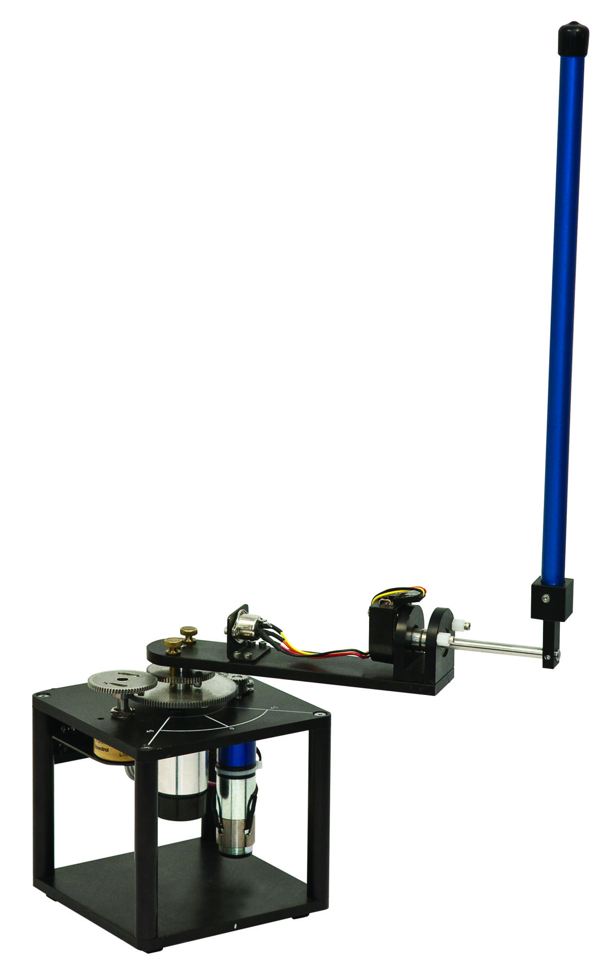

Figure 1.0 Rotary Inverted Pendulum

**Rotary Inverted Pendulum**

The rotary inverted pendulum spins about a fixed central axis. The arm that attaches to the fixed central axis holds the pendulum. The combination of the motor and sensors allow the pendulum to stand itself upright. Based on the pendulum's angle the motor can accelerate in both directions to counterbalance the falling rod. The assembly in Figure 1.0 above has an estimated cost of 200 to 500 dollars depending on its final configuration.

#### 

Figure 1.1 Reaction Wheel Inverted Pendulum

**Reaction Wheel Inverted Pendulum**

The reaction wheel inverted pendulum functions off torque by a spinning wheel at the top of the pendulum. The torque and counter-torque used to move the pendulum left or right can allow for the pendulum to have the ability to stand vertically when the PID loop is corrected. This specific example was made with a variety of Lego parts and the builder in the video we observed demonstrates that his loop works with a variety of weights and modifications.

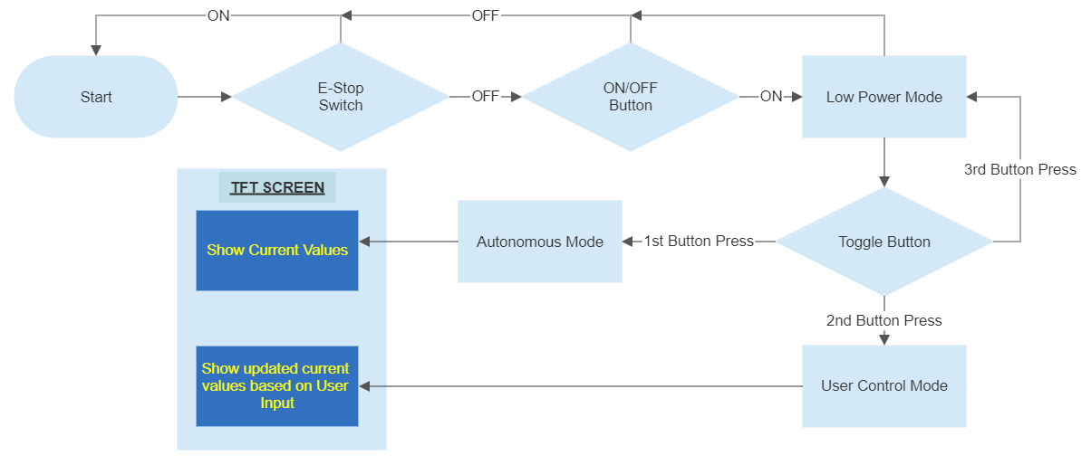

Figure 1.2 System Operational Flow Chart

Figure 1.2 shows the flow of operations that the Atmega328P will perform in order to ensure the system is operating safely and efficiently. .

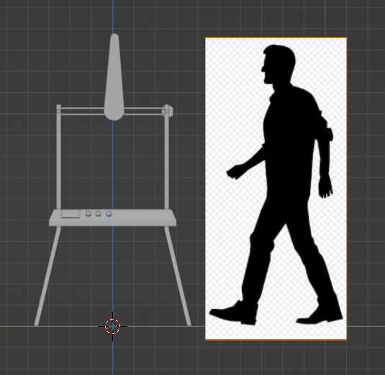

Figure 1.3 Design Scale

Figure 1.3 was a blender model used to give the group a sense of scale of the project and what we wanted it to look like using simple geometry.

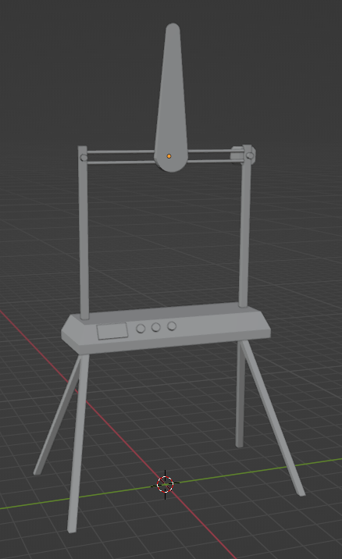

Figure 1.4 CAD Concept Design

Figure 1.4 is another view of our initial blender render to get an idea of the shape of the project

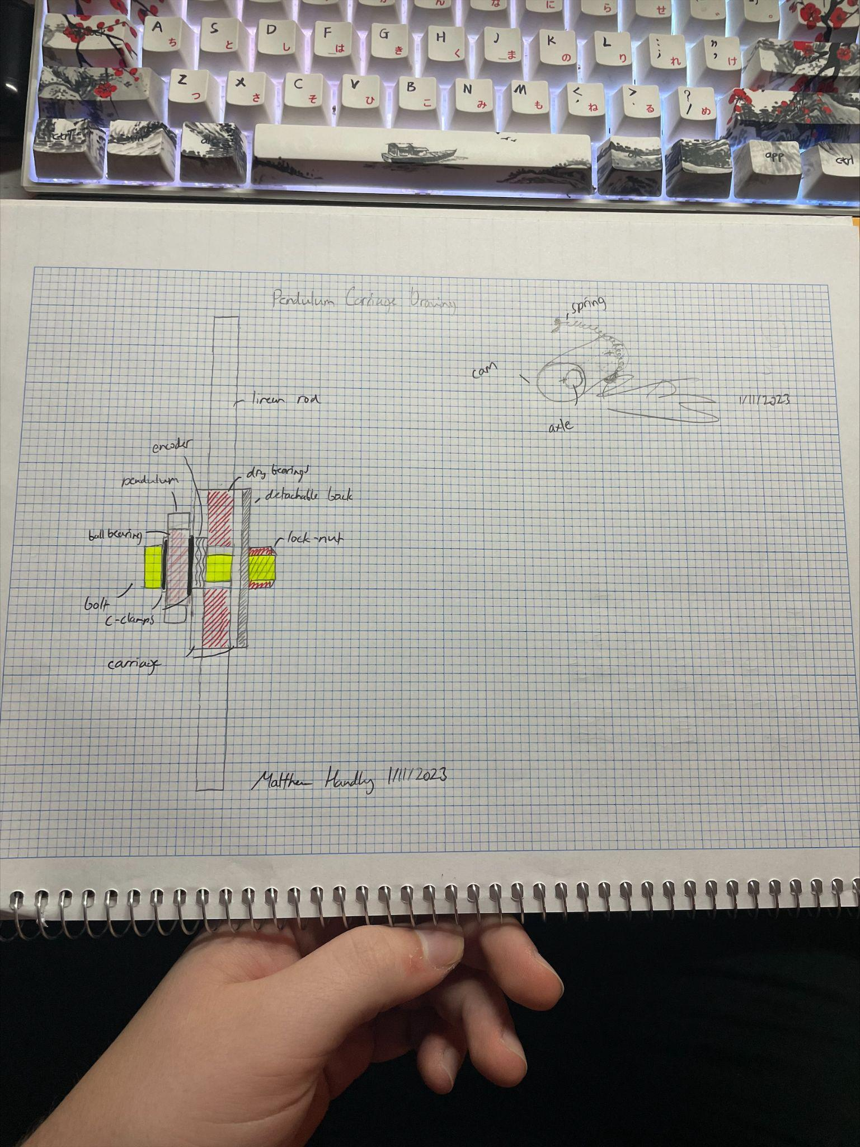

Figure 1.5 Initial Sketches

Figure 1.5 is a sketch of what the internals of the pendulum carriage will look like and how everything will be fastened together. It details how the pendulum will be attached to the encoder, and how to keep the belt secure inside of the carriage.

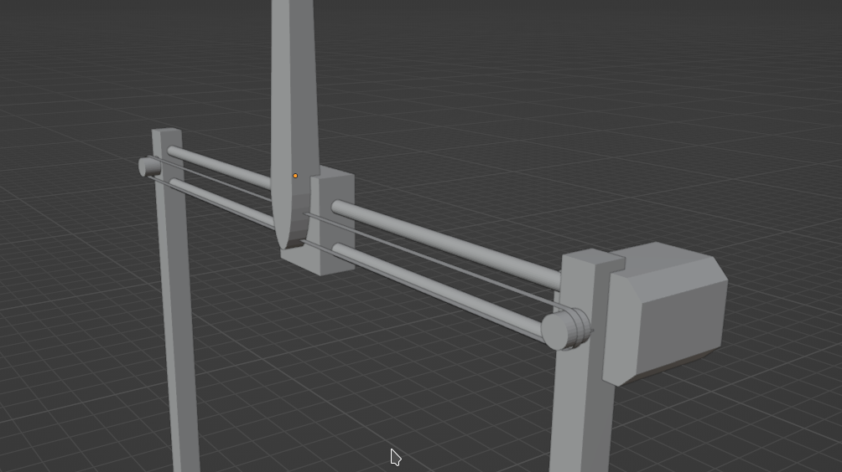

Figure 1.6 CAD Concept Design

Figure 1.6 shows a close up of the carriage and the carriage manipulating subsystems. It also allowed us to identify the need for a belt tensioning system located on the opposite side to that of the motor.

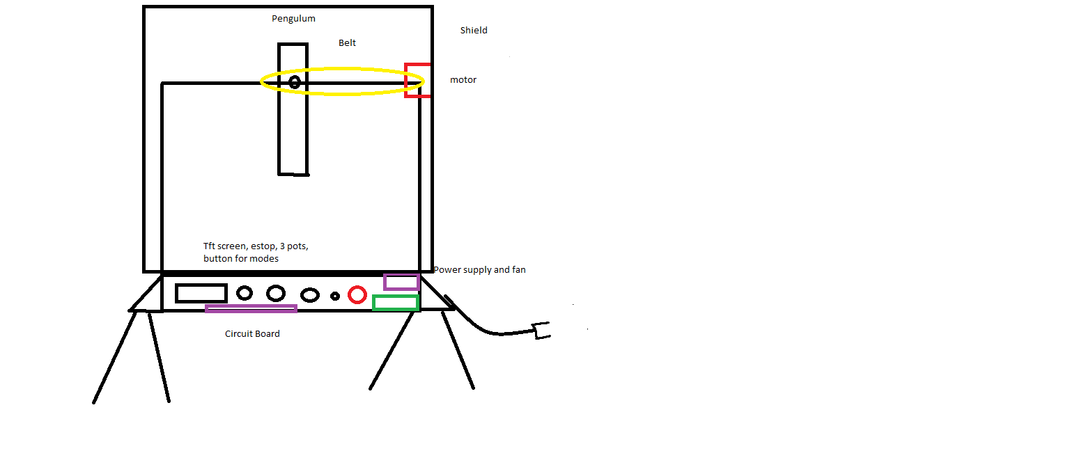

Figure 1.7 Initial Drawing

Figure 1.7 is a Microsoft paint drawing detailing where specific components necessary for operation would be located.

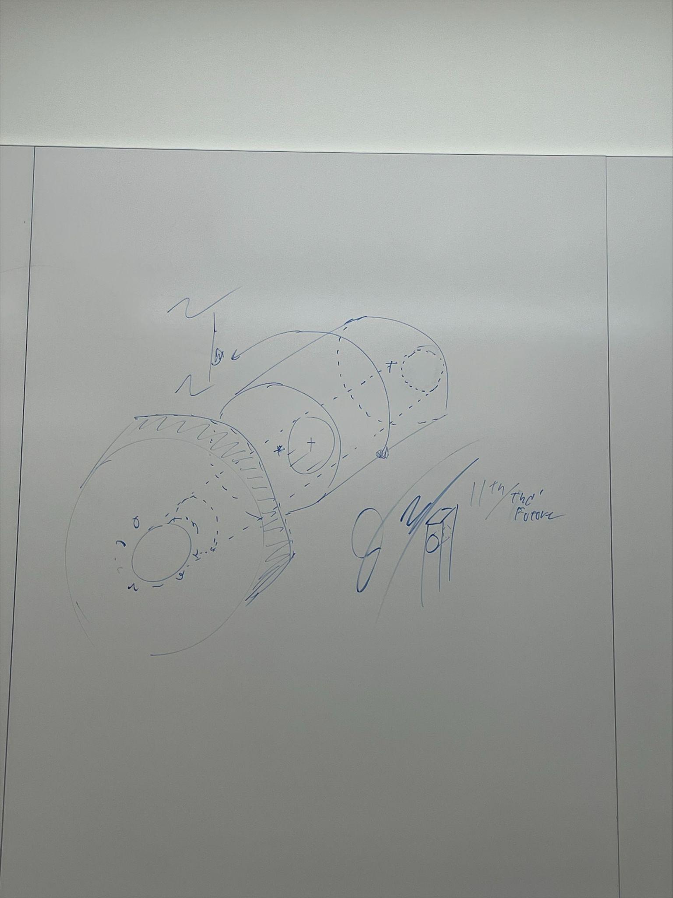

Figure 1.8 Initial sketch

Figure 1.8 shows the initial idea for the belt tensioning system and the eccentric cam that it would be mounted to.

## **Detailed Design**

### **Overall System**

The overall system consists of three main subsystems which interact with one another to create our finished design. Our main input is our encoder which will provide values through our electrical subsystem to our software subsystem. Our output is our motor which will receive values from our software subsystem, inevitably making our pendulum move. This cycle continues constantly to keep the pendulum balanced. Below are some images and diagrams to help further explain our subsystems and design features.

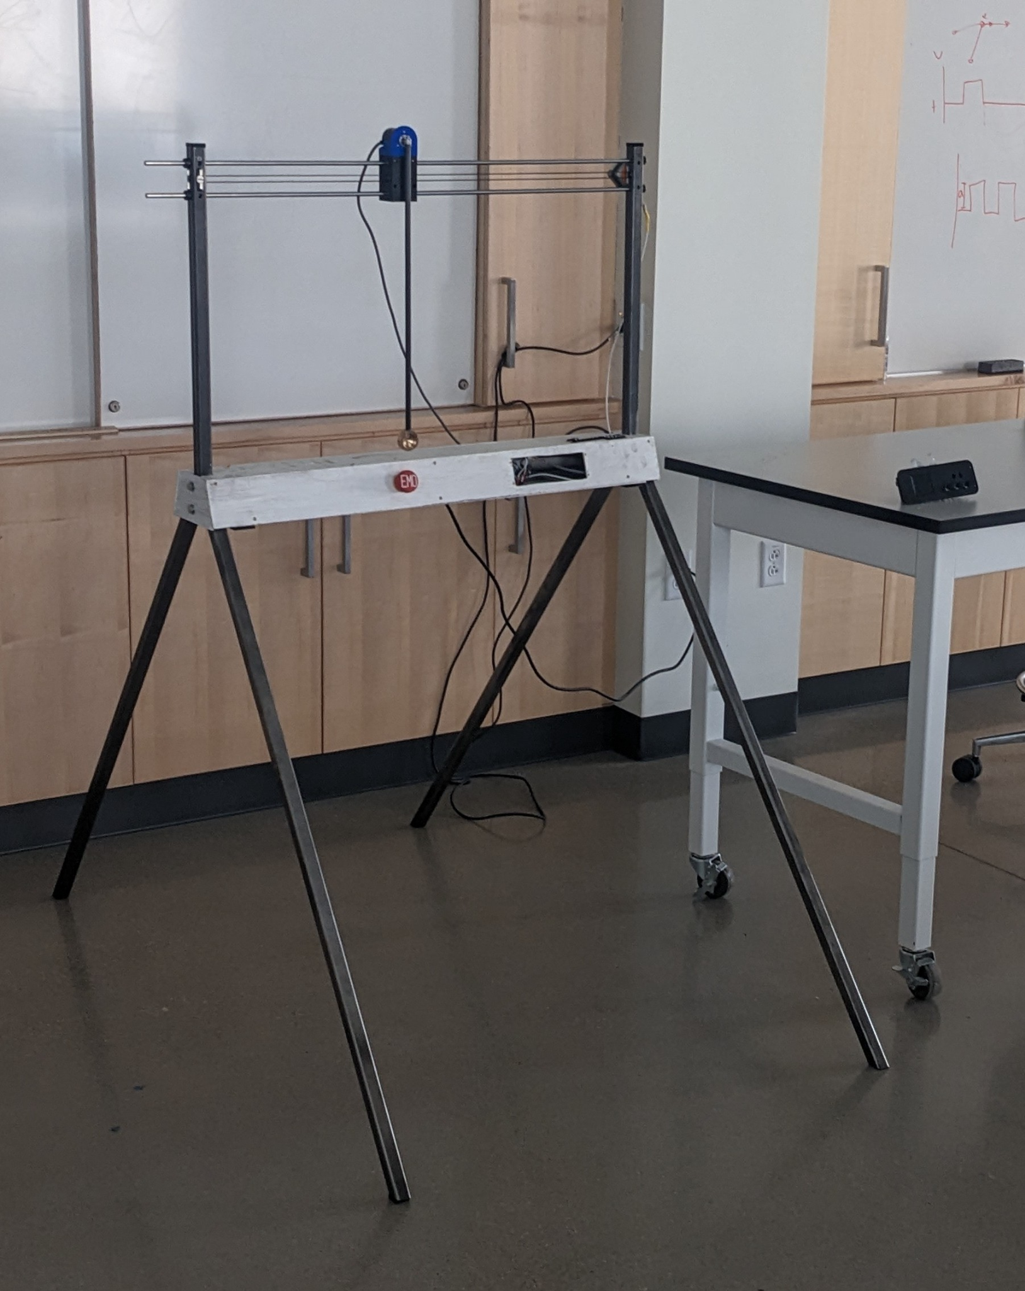

Figure 1.9 Full System Assembly

Figure 2.0 is the operational flow of the system. This photo shows the continuous loop between the encoder’s current position and the motor’s needed inputs to keep the pendulum balanced. These computations are performed inside of the Atmega328P microcontroller, and the output is fed to the motor controller before the motor is moved. These computations are what is fed to the user through the use of the TFT screen.

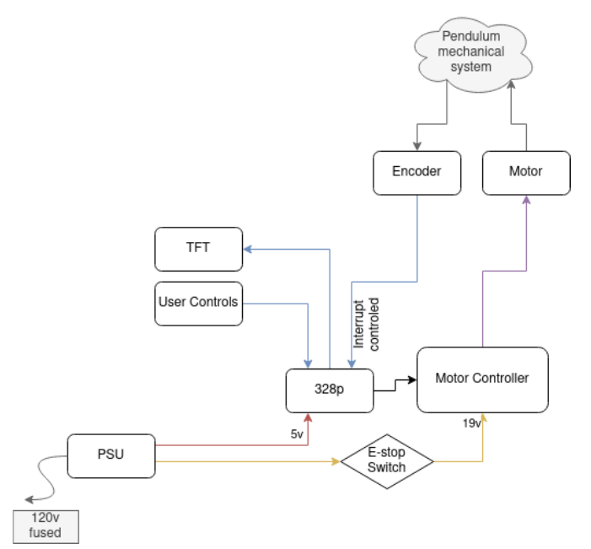

Figure 2.0 Operational Flow Chart

Figure 2.1 shows the different components that make up each subsystem in the system. These subsystems include the pendulum carriage in yellow, the carriage manipulation / movement system in red, the software in blue, and the electrical components in green.

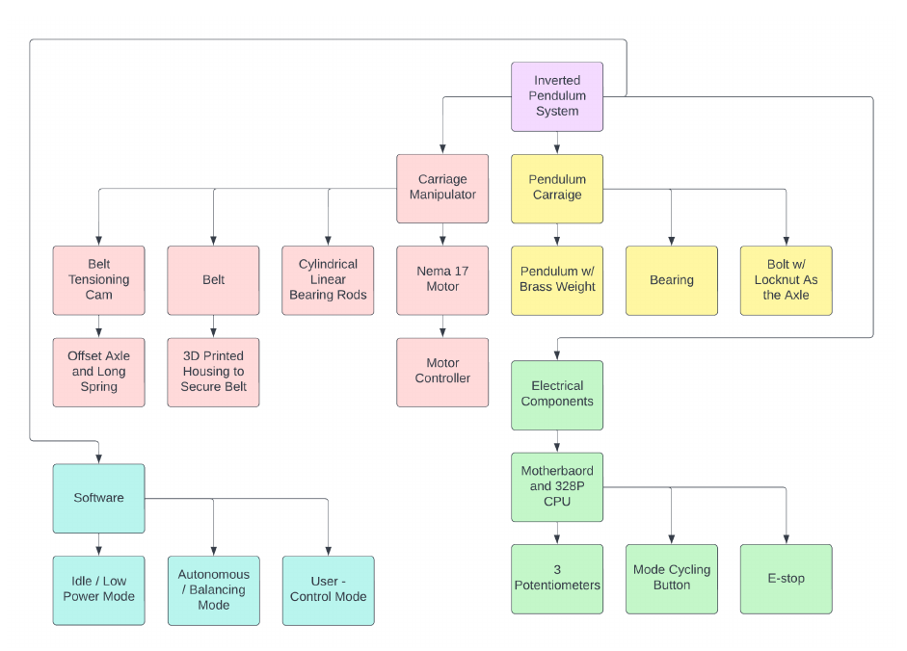

Figure 2.1 System Functional Block Diagram

### **Trade Studies**

| Trade Study Matrix | | | | | | | |
| --- | --- | --- | --- | --- | --- | --- | --- |
| WBS: | | Study: Motors | | Trigger Date | | | |
| Trade Configurations | | Trade Parameters | | | | Risk | Status and Assessment |
| Option | Description | Gear Ratio | Output Shaft Diameter | Full Motor Length | Cost |
| 1 | Nema 17 | 1:1 | 5 mm | 63 mm | $15.00 | -May not have enough torque | This motor seems like the all-around best decision and will be the go-to for this project. |
| 2 | Nema 23 | 1:1 | 6.35 mm | 97 mm | $20.00 | -May have too much torque  -Heavier  -Larger current draw | We plan on using this motor only as a back-up if the carriage becomes too heavy to be accelerated rapidly. |

Table 1.3 Motor Trade Study Matrix

Table 1.3 shows a detailed table of our motor trade study matrix. The purpose of this matrix is to compare different motors to determine which motor will be most appropriate for our project design. Each motor has a description as well as some key parameters and risks that we will base our final decision off.

| Trade Study Matrix | | | | | | | |
| --- | --- | --- | --- | --- | --- | --- | --- |
| WBS: | | Study: Frame Material | | Trigger Date | | | |
| Trade Configurations | | Trade Parameters | | | | Risk | Status and Assessment |
| Option | Description | Yield  Strength | Weight | Factor of Safety | Cost |
| 1 | Aluminum 6061-T6 | 35 MPa | 1.2 lbs/ft | 1.5 | $8/linear foot | Harder to service | Machining might require more time compared to steel. Does not rust |
| 2 | Mild Steel | 250 MPa | 2lb/ft | 1.15 | $5/linear foot | Prone to rust | Cost efficient and durable |

Table 1.4 Frame Material Trade Study Matrix

Table 1.4 shows a detailed table of our frame material trade study matrix. The purpose of this matrix is to compare different materials to determine which material will be most appropriate for our frame design. Each material has a description as well as some key parameters and risks that we will base our final decision off.

| Trade Study Matrix | | | | | | | |
| --- | --- | --- | --- | --- | --- | --- | --- |
| WBS: | | Study: Pendulum | | Trigger Date | | | |
| Trade Configurations | | Trade Parameters | | | | Risk | Status and Assessment |
| Option | Description | Yield Strength | Weight | Factor of Safety | Cost |
| 1 | Carbon Fiber | 3 GPa | 0.034 lbf / ft | 2.7 * 10^3 | $4.86 / foot | -High price | This will be used for our final product |
| 2 | PVC | 3.45 MPa | 0.18 lbf / ft | 31.34 | $0.47 / foot | - Low fatigue strength and product life cycle  - Heavy | This option would be great for prototyping for testing of the system. |

Table 1.5 Pendulum Trade Study Matrix

Table 1.5 shows a detailed table of our pendulum material trade study matrix. The purpose of this matrix is to compare different materials to determine which material will be most appropriate for our pendulum design. Each material has a description as well as some key parameters and risks that we will base our final decision off.

### **Mechanical System**

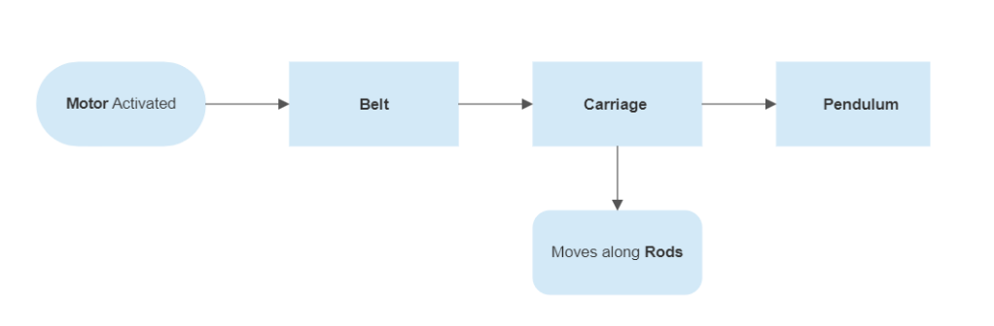

Figure 2.2 Subsystem Mechanical Design

Figure 2.2 Shows the transfer of power between the mechanical components in order to balance the pendulum.

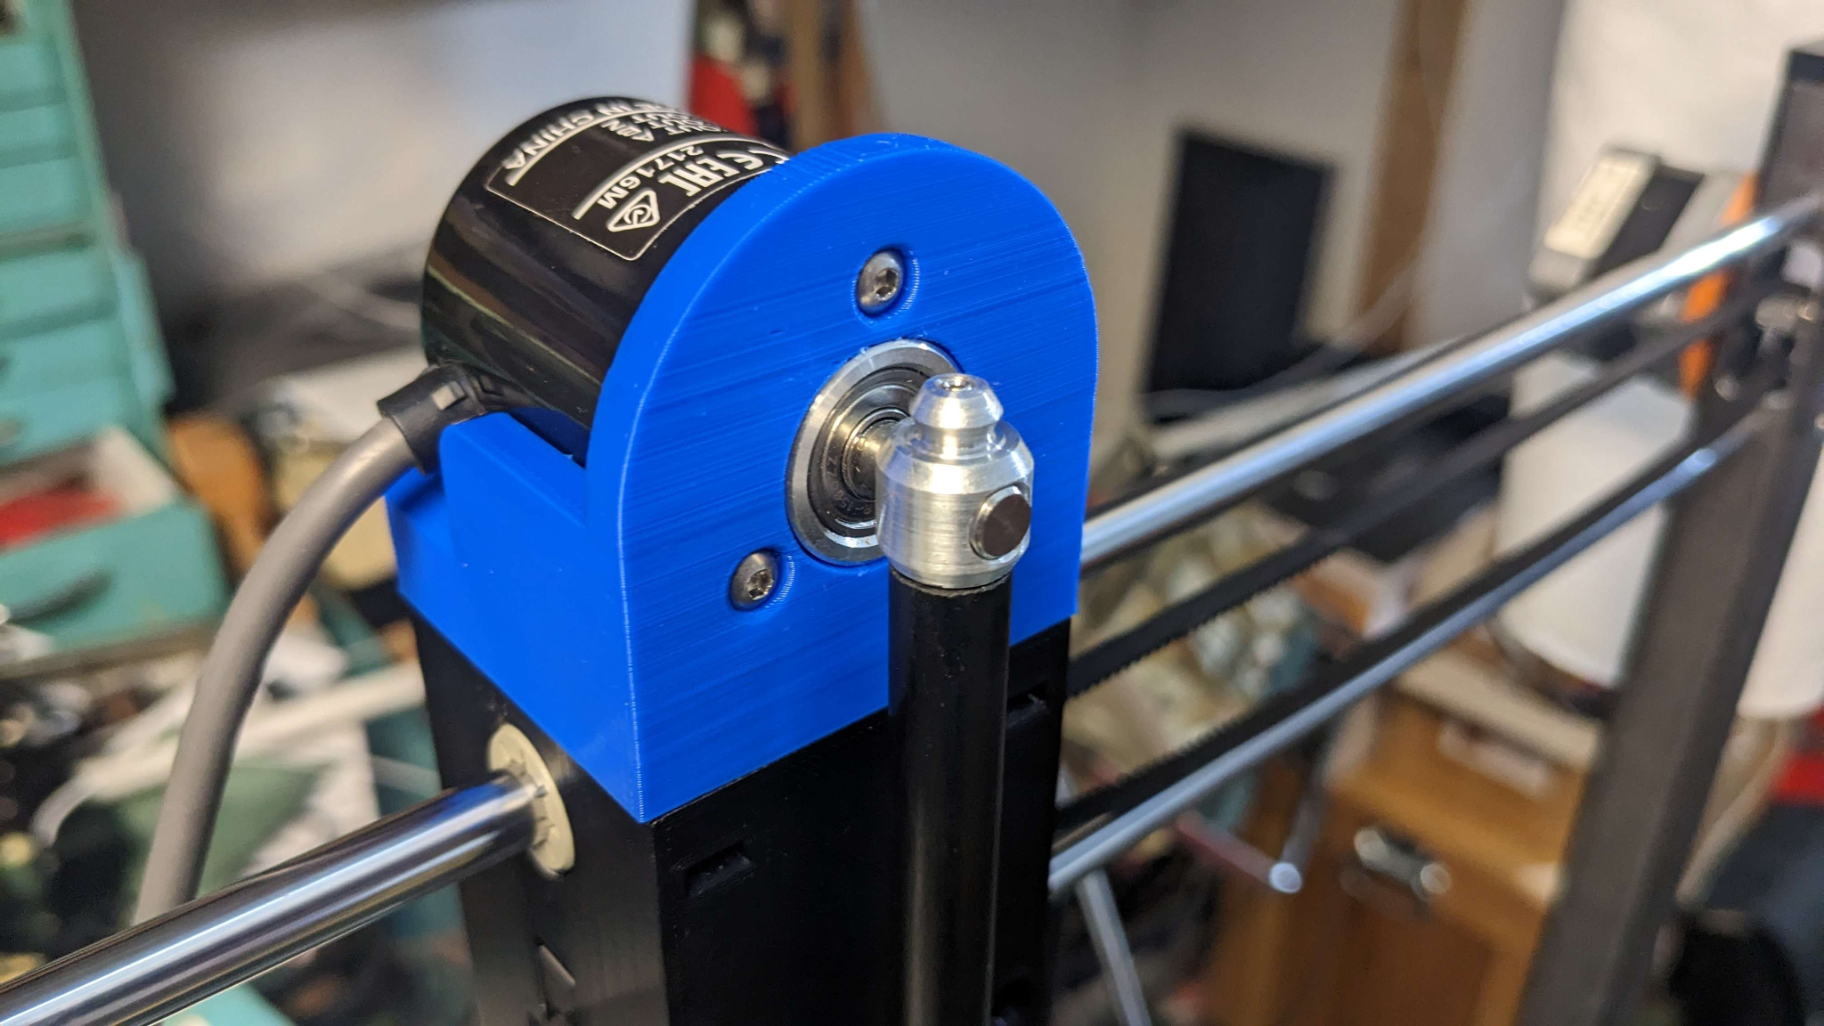

Figure 2.4 Carriage and Pendulum Components

Figure 2.4 Shows the assembled carriage for the pendulum’s pivot point, its connection to the motor encoder, and the pendulum’s connection to its pivot point.

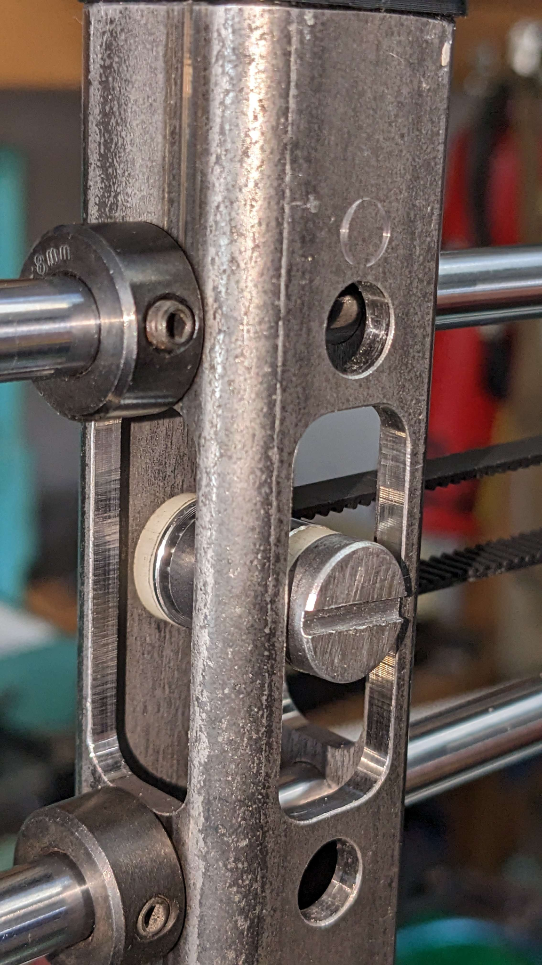

Figure 2.5 Carriage and Pendulum Components

Figure 2.5 Shows the assembled belt tensioning assembly and how the linear rods are secured to the frame.

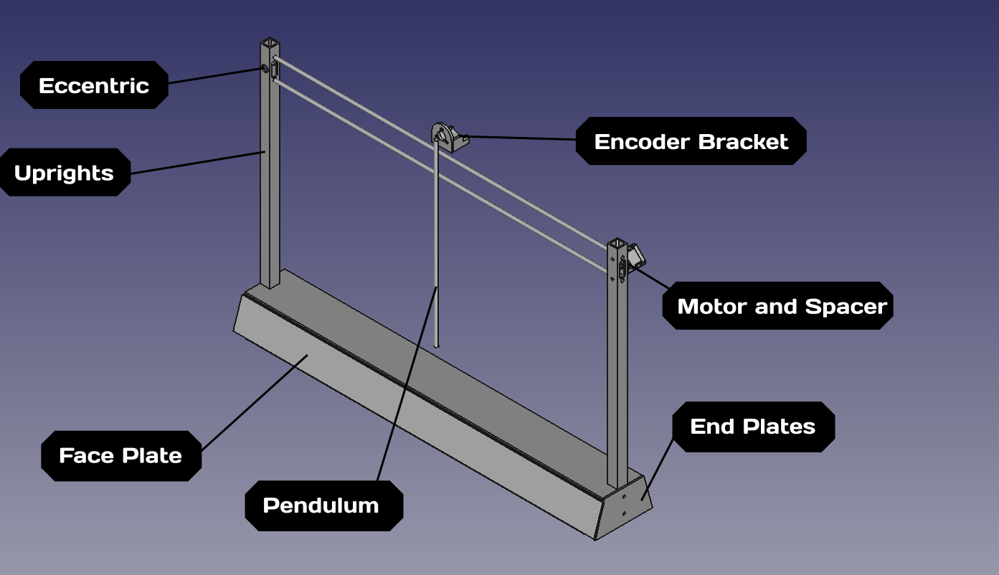

Figure 2.6 Carriage and Pendulum Components

Figure 2.6 Shows a simplified view of the mechanical system and identifies the location of the components used.

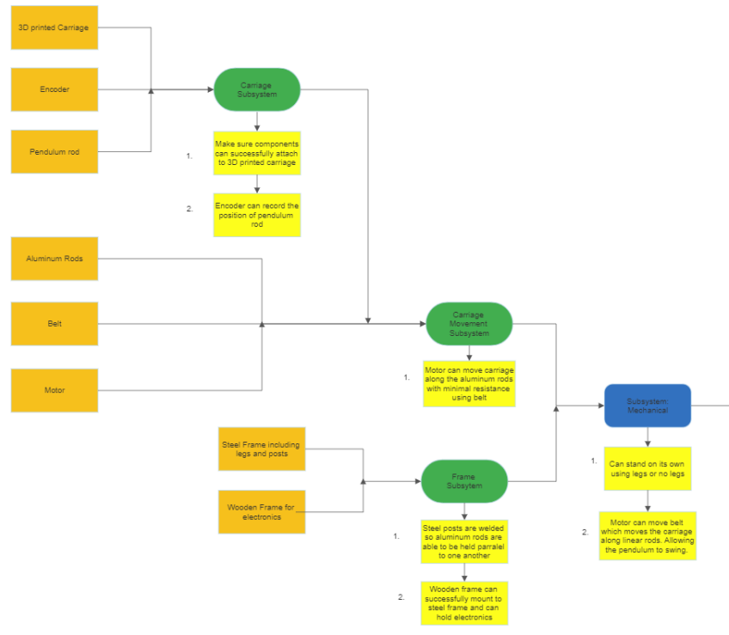

Figure 2.7 Mechanical Subsystem Flow Diagram

Figure 2.7 shows our mechanical subsystem flow. Some main subcomponents are: carriage movement subsystem, and frame subsystem. Our carriage movement subsystem is composed of our carriage, aluminum rods, belt, and motor. The frame subsystem is composed of steel frames such as legs and posts. As well as our wooden frame for containing our electronics. Some key tests we want our mechanical subsystem to pass are: can successfully stand, as well as being able to move the carriage.

### **Software System**

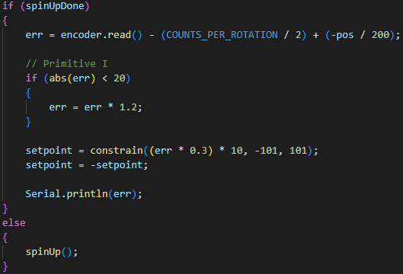

Figure 2.7.1 PID Balancing Control Algorithm

Figure 2.7.1 Shows our PID algorithm for balancing the pendulum in an upright state. The algorithm works by first creating a proportional behavior between how fast the motor spins compared to how close we are to balance. The farther away the pendulum is from a balanced state, the faster the motor spins to catch the pendulum and vice versa when the pendulum is close to balanced. This proportional loop then creates an oscillating behavior which makes the pendulum wiggle back and forth infinitely, and the pendulum will never reach a balanced state. An I term is then used to take the integral of the proportional loop to find the area between our oscillating behavior and our balanced state, and the I term limits this area to be as small as possible. The result is a critically damped system. However, the PI loop is often quite slow. As a result, a derivative term is added to take the derivative of the PI loop. This accelerates the rate at which the system reaches a balanced state. The effects of the different loops are illustrated in figure 2.7.2.

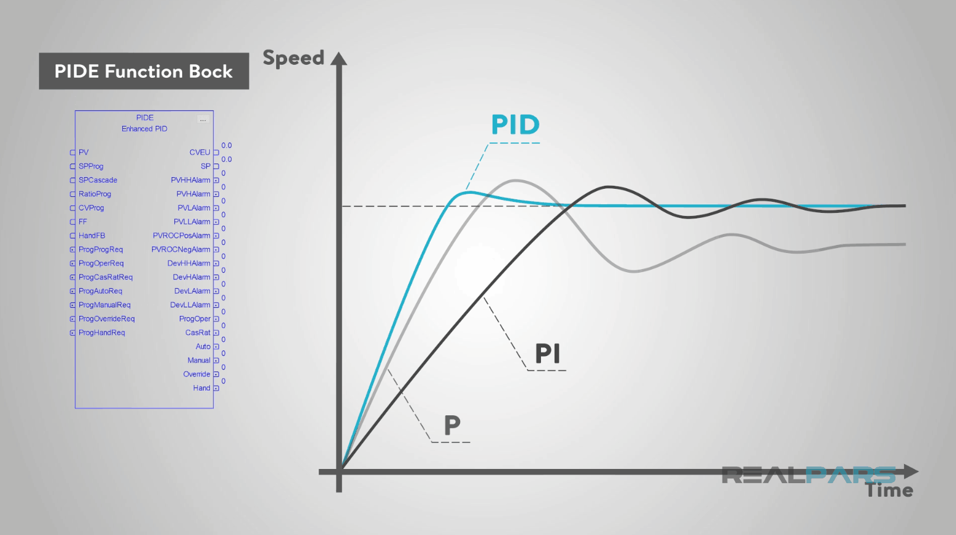

Figure 2.7.2 Difference Between P, PI, and PID Loop Infographic

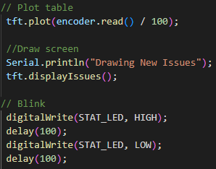

[Figure 2.7.3 TFT Screen Plotting and Constant Display](https://github.com/KenwoodFox/EG-310-InvertedPendulum/blob/b259eed9e04416b789770526ae1d8d280c4eb757/Firmware/src/main.cpp#L87-L98)

Figure 2.7.3 shows how the TFT screen is set up and what is to be displayed on the colored TFT screen.

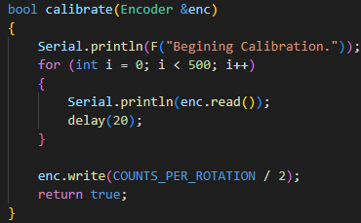

[Figure 2.7.4 Encoder Calibration](https://github.com/KenwoodFox/EG-310-InvertedPendulum/blob/main/Firmware/src/calibrate.h)

Figure 2.7.4 shows how the encoder resets itself on start-up. The pendulum is hanging straight down if it has not been used in a while. If the system has been used recently and the pendulum is still swinging, the encoder will record the length of the swings for five seconds before performing a calculation that takes into account the frictional loss of swing length to find the center point where the pendulum would be hanging straight downwards.

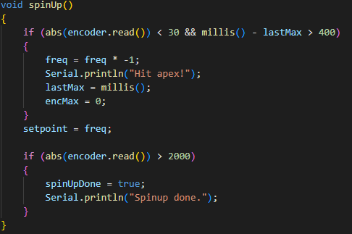

[Figure 2.7.5 TFT Screen Plotting and Constant Display](https://github.com/KenwoodFox/EG-310-InvertedPendulum/blob/f2515b6f3a41df3dc01b7c2c71bf7018b95d281b/Firmware/src/main.cpp#L91-L107)

Figure 2.7.5 shows the harmonic oscillation code that gets the pendulum into an inverted state. The code works by detecting the moment that the pendulum first begins to fall at the end of its swing upwards. Once detected, the robot applies a constant, linear force that had been calculated in advance to boost the velocity of the pendulum as it makes its swing in the opposite direction. This process is repeated until the pendulum is inverted.

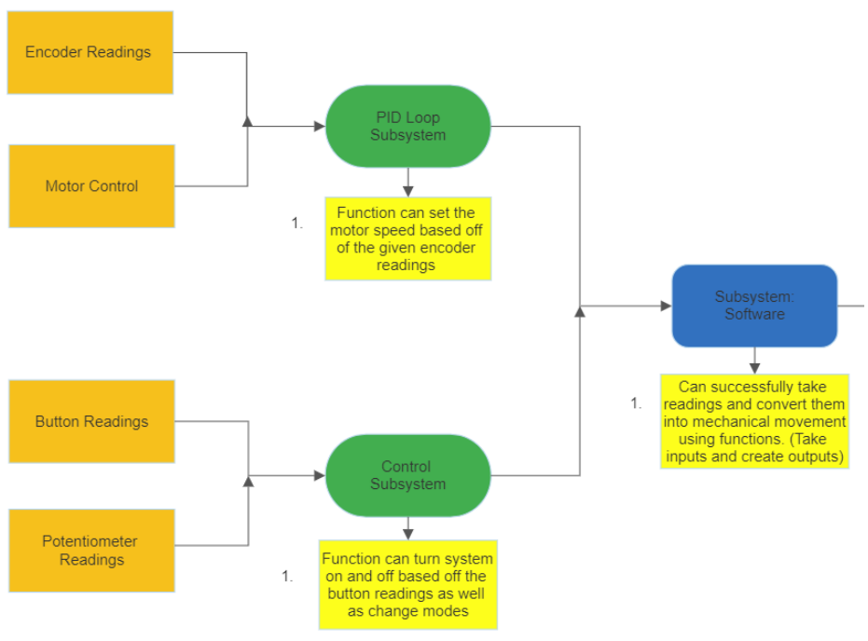

Figure 2.8 Software Subsystem Flow Diagram

Figure 2.8 shows our software subsystem flow. The two main subsystems are: pid loop subsystem and the control system. The key components of our pid loop subsystem are: encoder readings, motor control. The key components of our control subsystem are: button readings, potentiometer readings. Some key tests we want our software subsystem to pass are: can successfully read inputs from and provide corresponding outputs.

### **Electrical System**

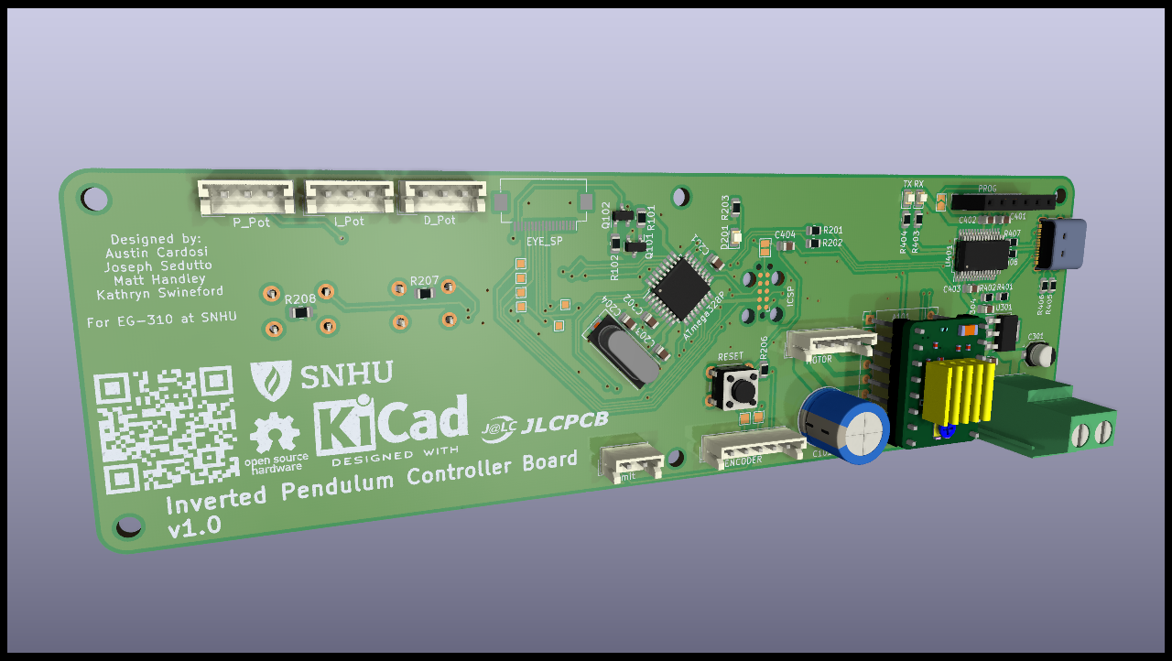

[Figure 2.9 Subsystem Electrical Design](https://github.com/KenwoodFox/EG-310-InvertedPendulum/tree/main/Hardware)

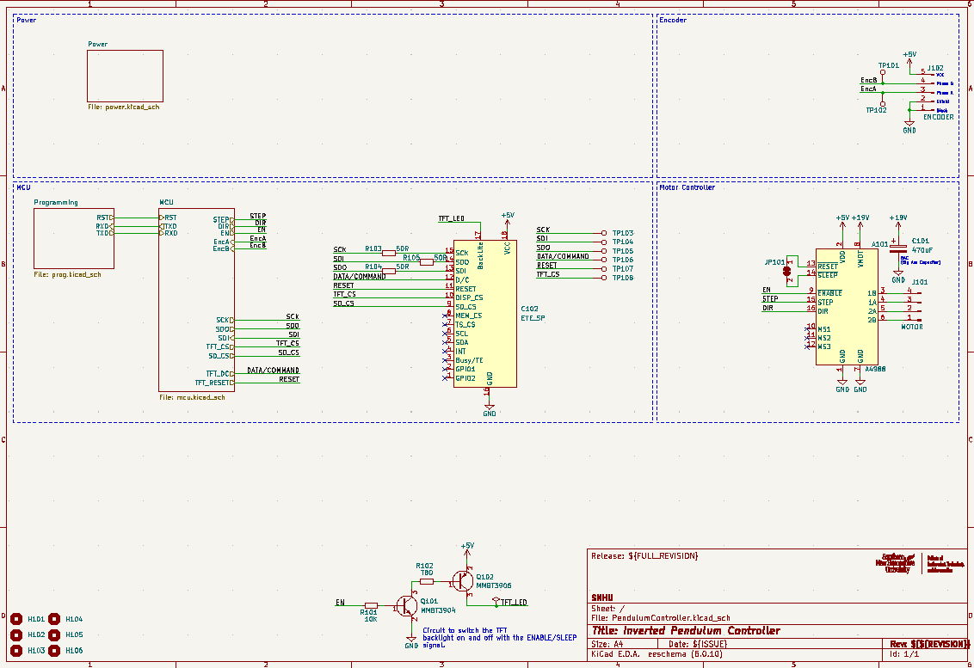

[Figure 3.0 Electrical subsystem Schematic](https://github.com/KenwoodFox/EG-310-InvertedPendulum/tree/main/Hardware)

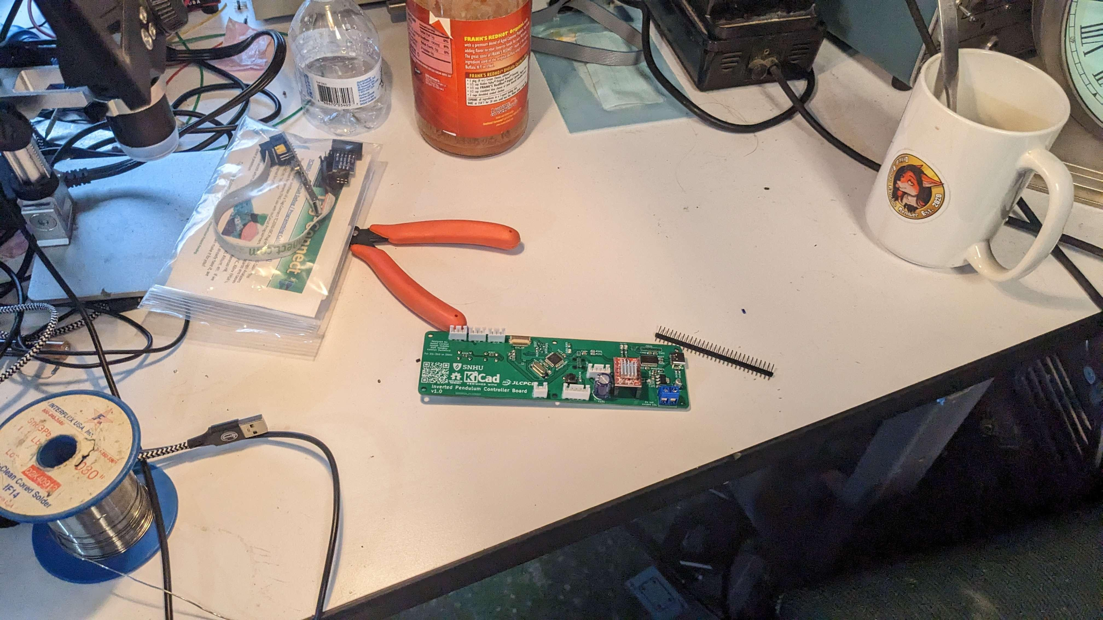

Figure 3.0.1 Electrical subsystem Schematic

Figure 3.0.1 Shows the physical circuit board with all its components attached.

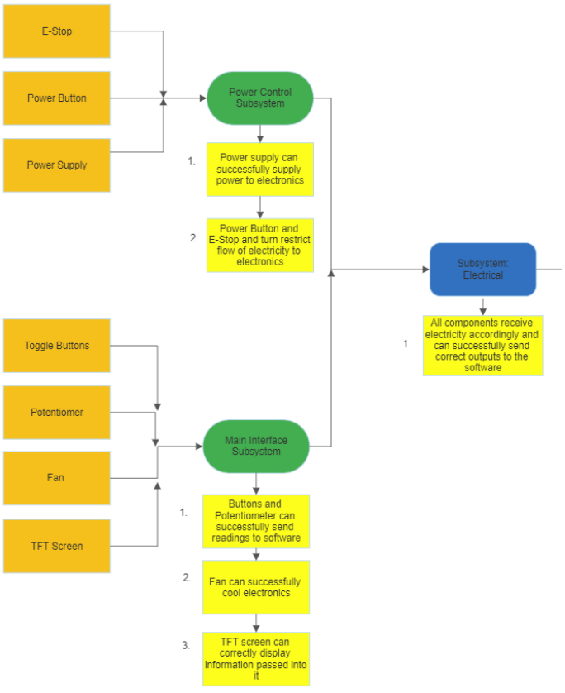

Figure 3.1 Electrical Subsystem Flow Diagram

Figure 3.1 shows our electrical subsystem. The two main subsystems are: power control and the main interface. The key components of our power control subsystem are: emergency stop, power button, and the power supply. The key components of our main interface are: toggle buttons, potentiometers, fan, and the TFT screen. Some key tests we want our software subsystem to pass are: can successfully power components as well as send outputs to the software subsystem.

### **Detailed Design**

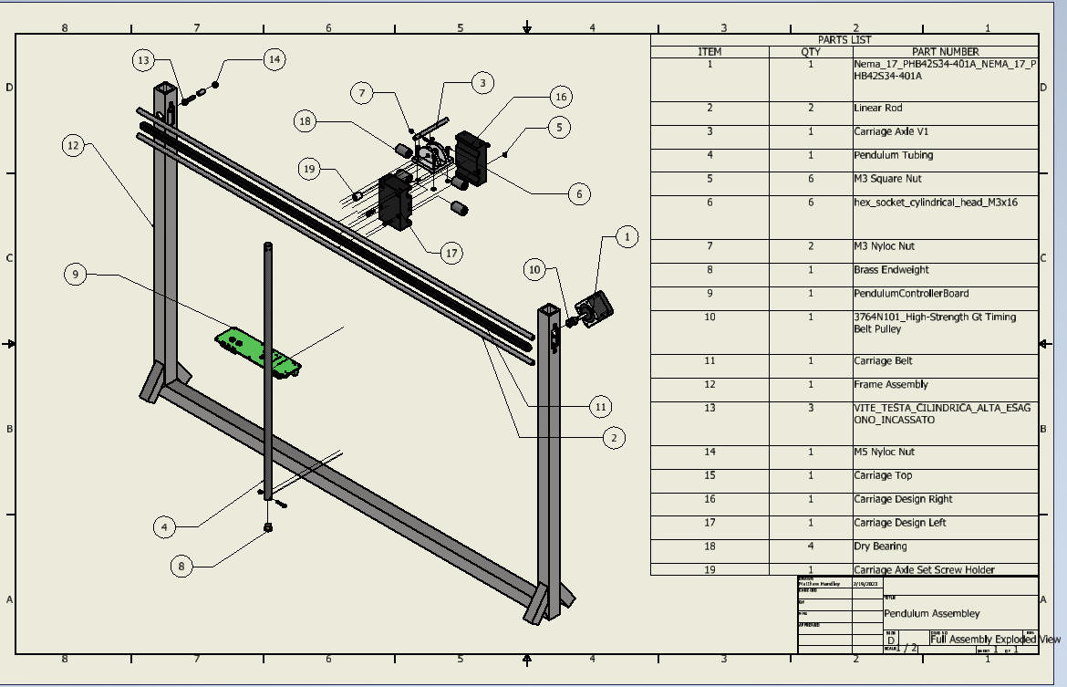

[Figure 3.2 Detailed Design](https://github.com/KenwoodFox/EG-310-InvertedPendulum/tree/main/CAD)

Figure 3.2 shows an exploded view of our detailed design. Pictured in our detailed design: Nema Motor (1), Linear Rod (2), Carriage Axle (3), Pendulum Tubing (4), M3 Square Nut (5), Hex Socket Head (6), M3 Nyloc Nut (7), Brass Endweight (8), Pendulum Controller Board (9), Timing Belt Pulley (10), Carriage Belt (11), Frame Assembly (12), M5 Nyloc Nut (14), Carriage Top (15), Carriage Design Right (16), Carriage Design Left (17), Dry Bearing (18), Carriage Axle Set Screw Holder (19).

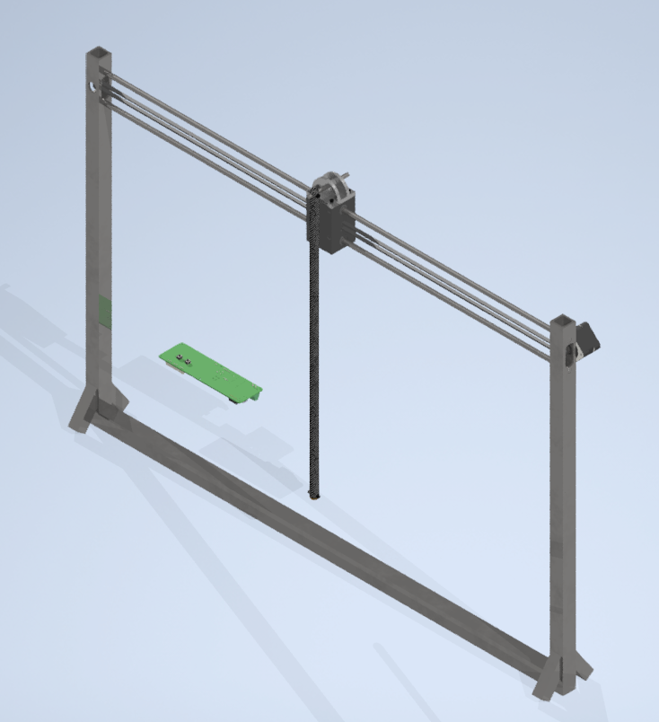

[Figure 3.3 Assembled Detail Design](https://github.com/KenwoodFox/EG-310-InvertedPendulum/tree/main/CAD/Matt's%20CDR%20CAD%20Files%20(Inventor%20Professional%20Format))

### **Health and Safety Features**

In our design we have incorporated some safety and health features to minimize potential risk. All electrical components are grounded to prevent dangerous discharge. A manual emergency stop button was incorporated in case of emergency. Easy access to the embedded components have been implemented to clean the machine and remove dust and debris. The internal temperatures of our design have been tested and do not reach dangerous temperatures.

## **Fabrication and Integration**

Fabrication began with first testing if all of the electrical components were working individually before soldering them to the circuit board

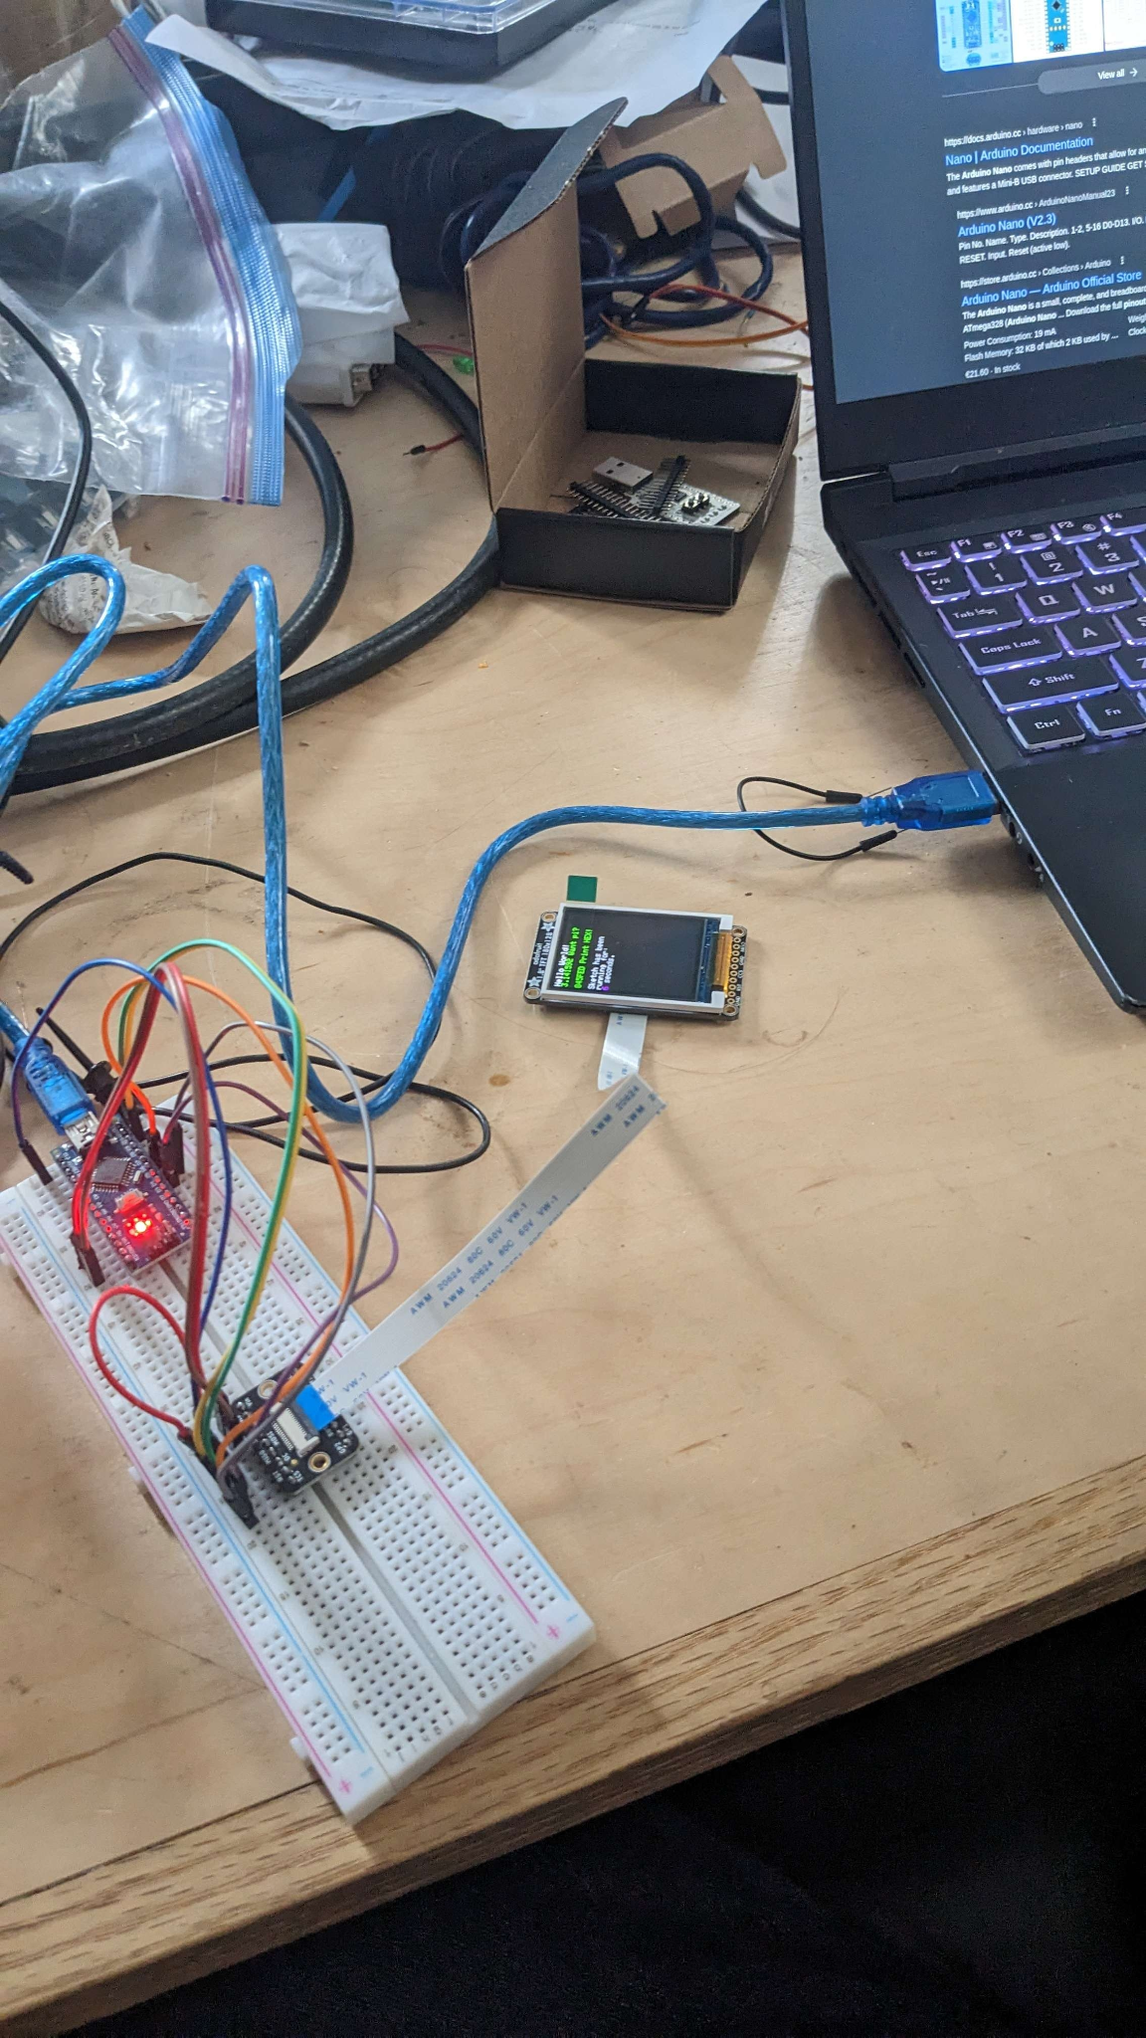

Figure 3.4 Electrical Component Testing

After all components had been tested, the circuit board was ordered through Joe Donovan. When the circuit board came in a week later, Joe (Sedutto) used the soldering stencil to apply the solder to the circuit board in the correct places. The board was then baked to set the soldier and allow for components to be attached to the board.

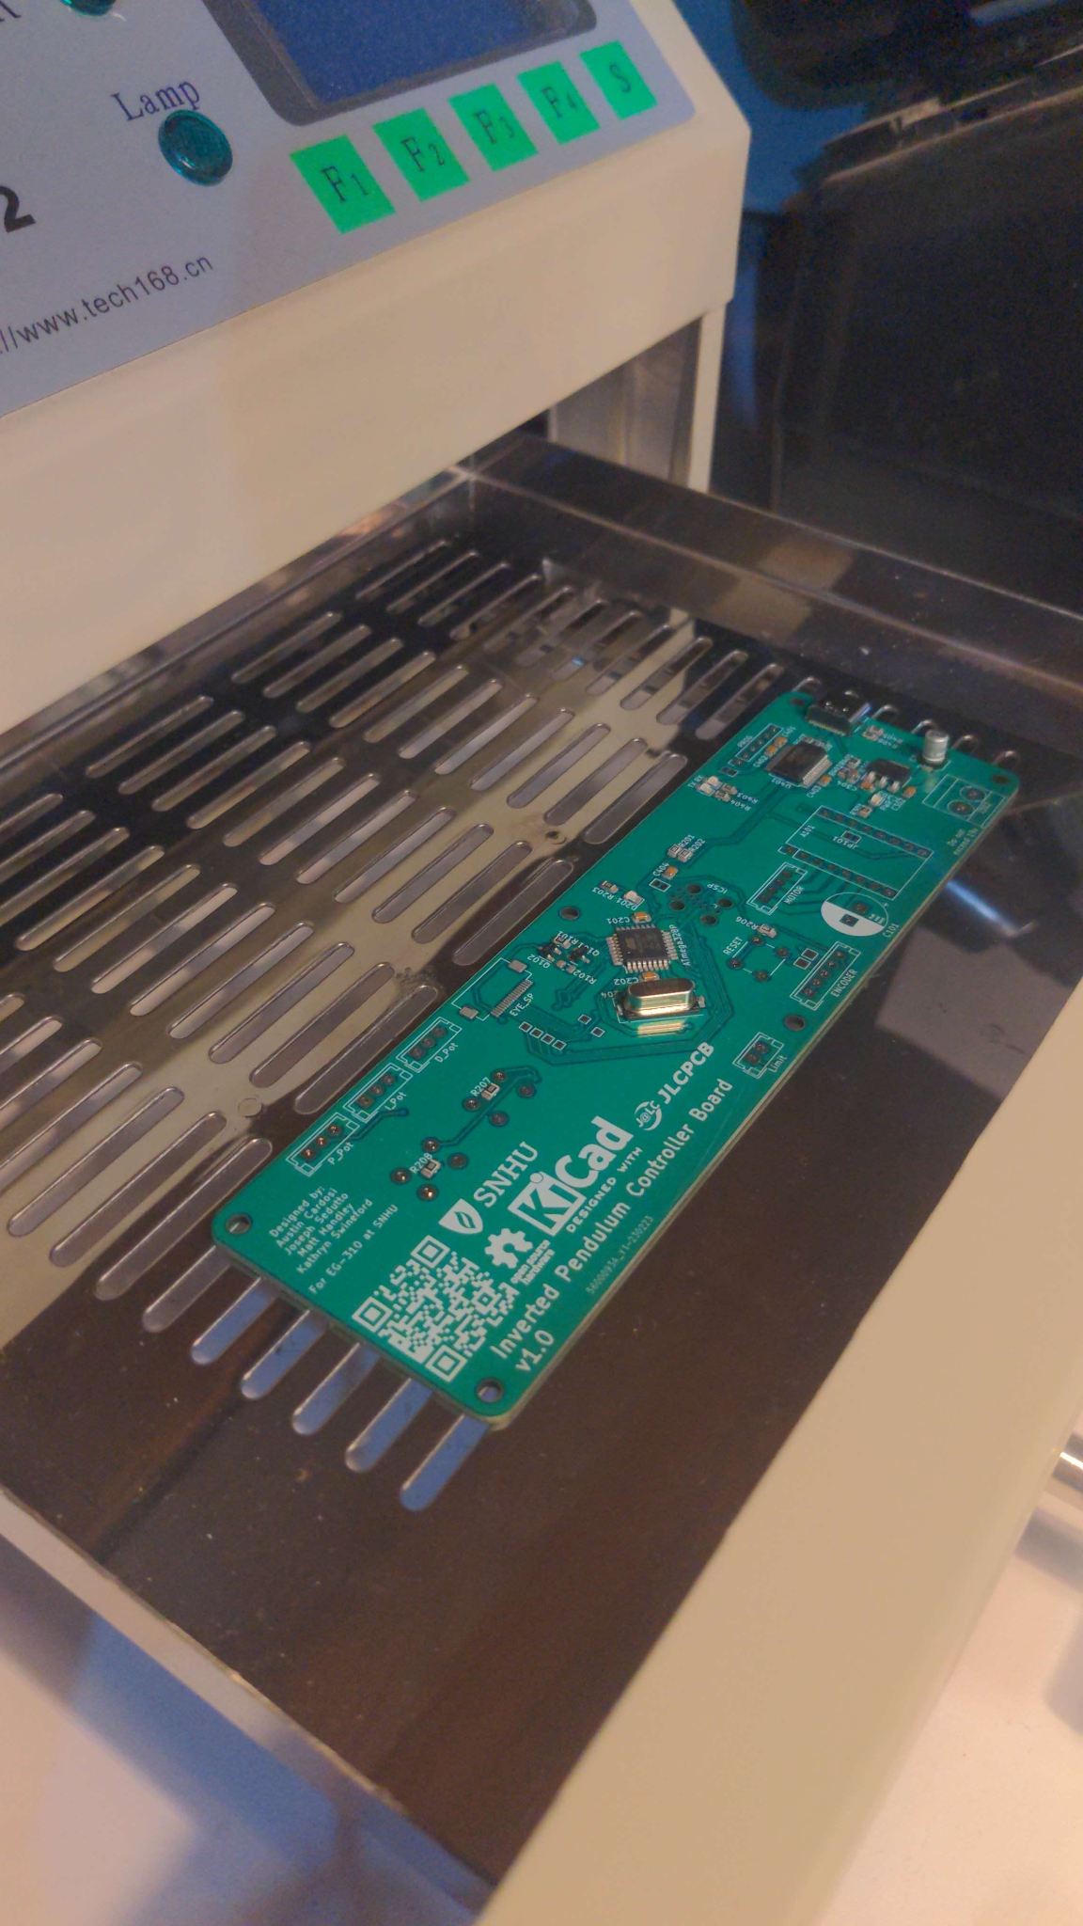

Figure 3.5 Soldering stencil



Figure 3.6 Circuit Board

Once the circuit board had been tested and all connections were secure and properly grounded, work on the mechanical system began. The goal was to get the 3D printed user panel and the 3D printed carriage finished up first.

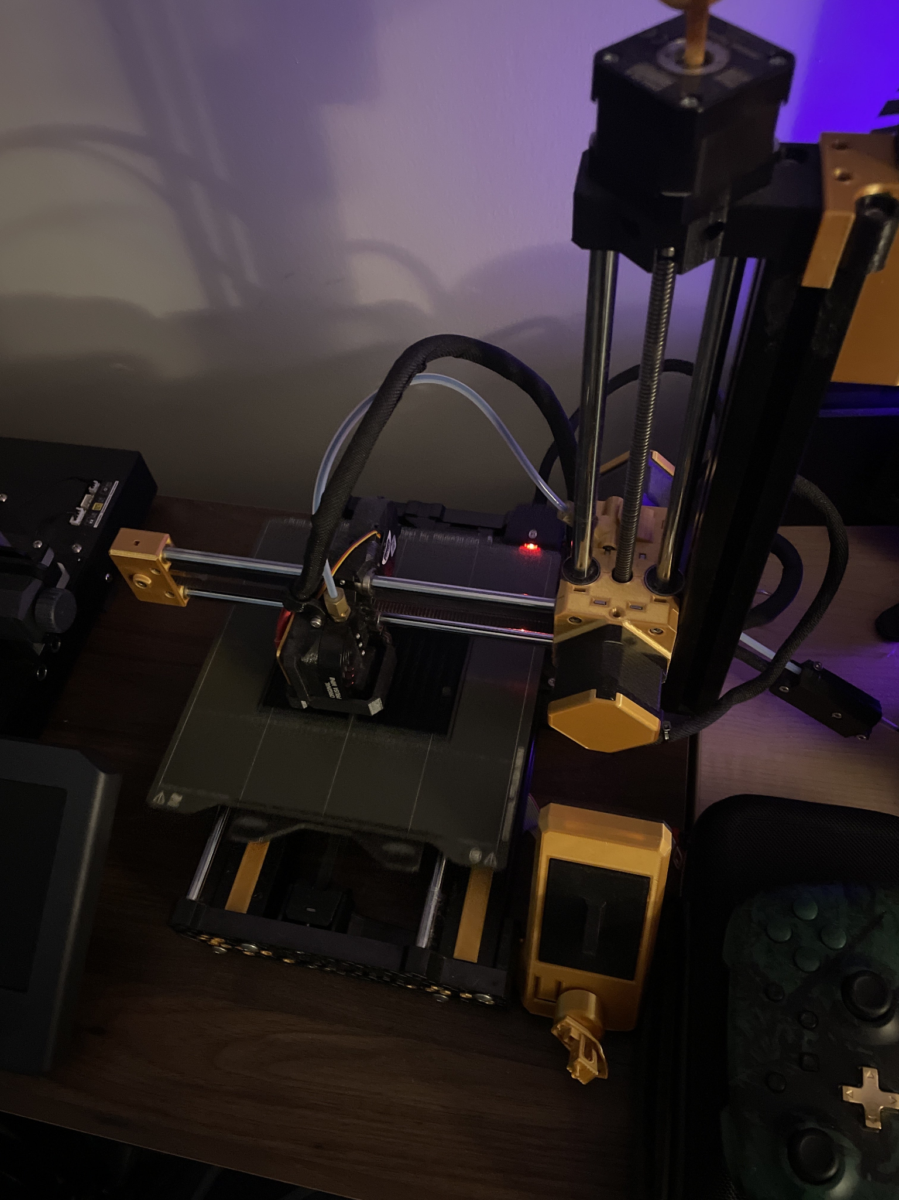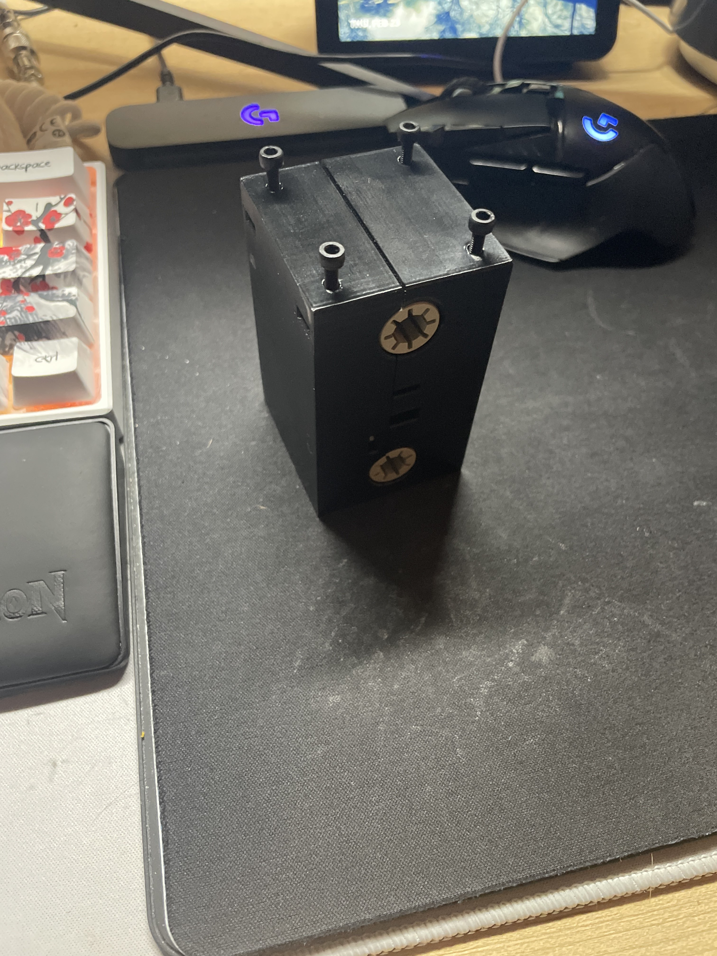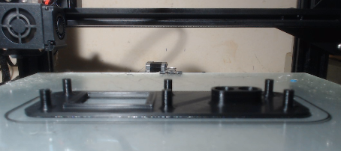

Figure 3.7 3D Printing

After the 3D prints had finished, the goal was to make the pieces of the frame and weld them together. The first step was to cut the steel stock down into the pieces that the legs would slide onto. And, the hollow steel tubing would be cut down to its proper size as well.

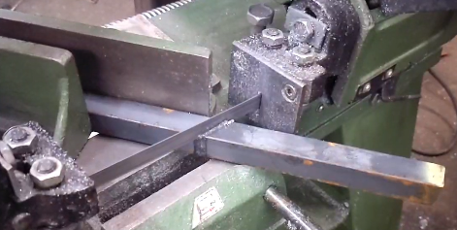

Figure 3.8 Cutting Steel Stock

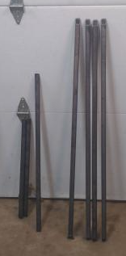

Figure 3.9 Steel Legs

The Circuit Board was then mounted to the 3D print and tested with the encoder.

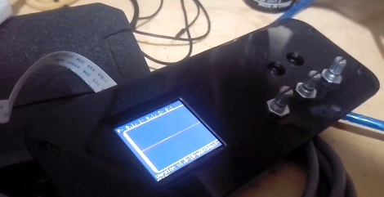

Figure 4.0 TFT Screen

Unfortunately, the hollow tubes had a welding bead that got in the way of them being able to easily slip onto the steel stock that had been cut. As a result, an angle grinder was used to cut a slot that the welding bead could slip through when the legs were slotted on.

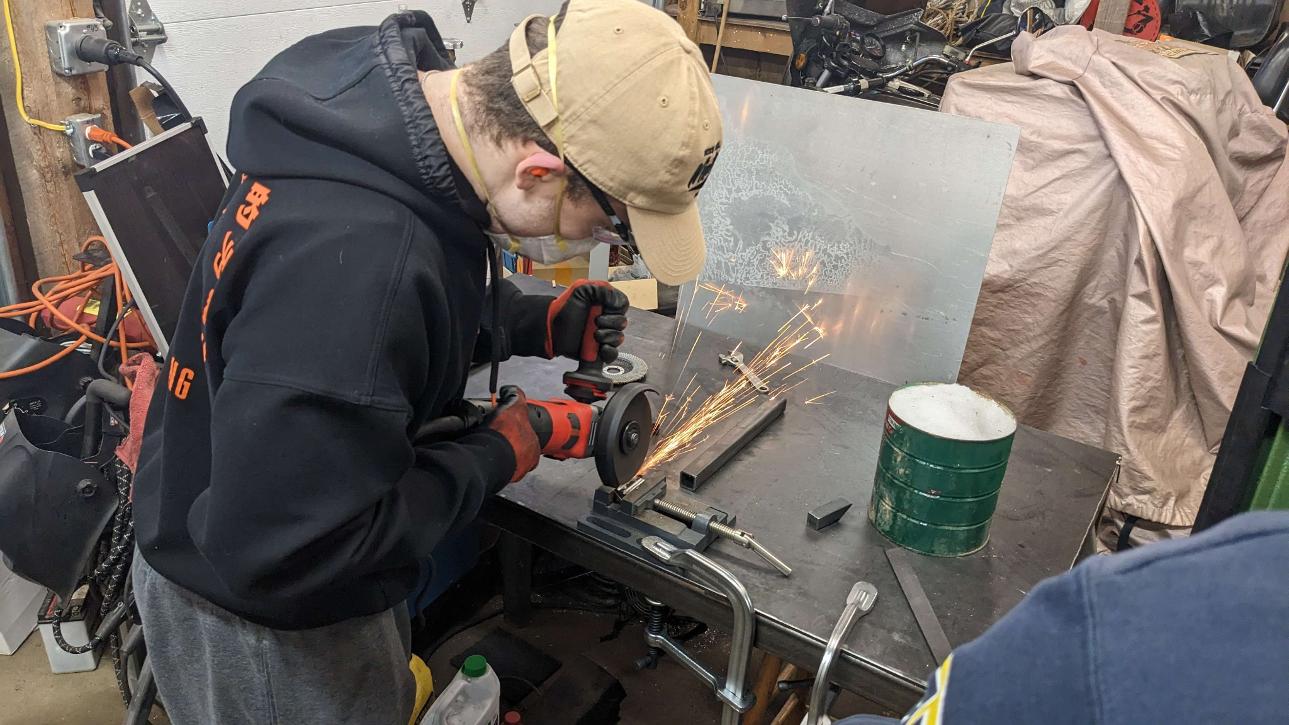

Figure 4.1 Using Angle Grinder

Afterwards, the mounting geometry for the motor, the eccentric, and the steel rods had to be cut into the hollow steel tubing. The fits and geometry of these cuts needed to be extremely accurate so the CNC machine was operated by Joe’s brother, Michael, to make the cuts. The CNC allowed for all fits to be kept square and an easier welding process.

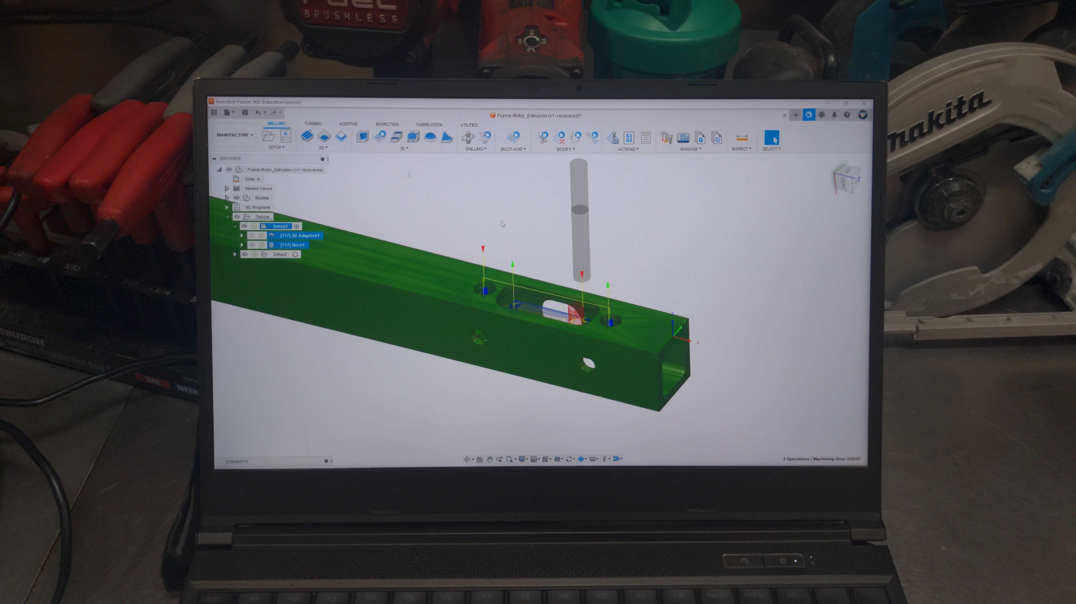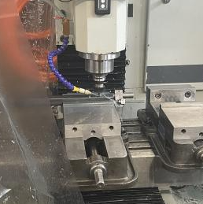

Figure 4.2 CNC Machining

Then, it was time to weld the frame together. Tig welding was used.

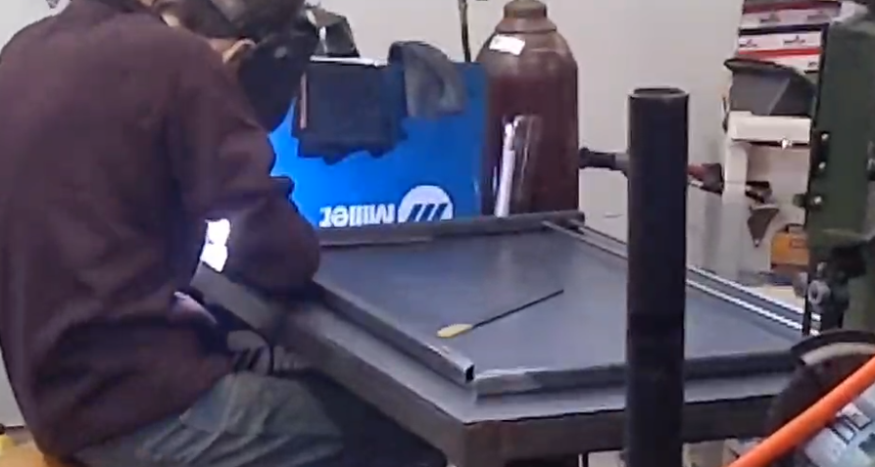

Figure 4.3 TIG Welding

Once welding was complete, the group focused their attention to the mounting of the electronics. And with that, the wooden housing had to be fabricated for the electronics. A trapezoidal shape was elected as it would add visual interest to the machine. The fit of the linear rods was also tested at this point and the carriage was added to the assembly. The power supply, user interface, and emergency stop were also mounted to the wooden housing.

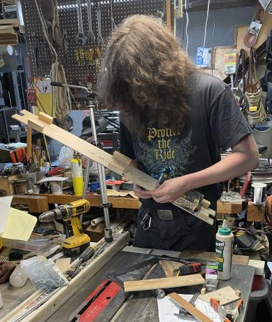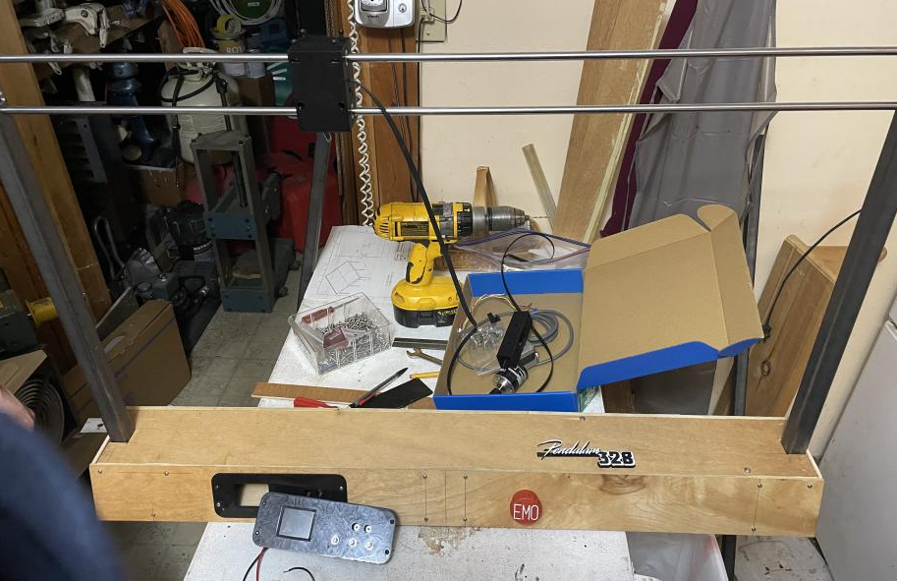

Figure 4.4 Wooden Frame

Before the wood was finally faceted together, the housing was taken apart and primed and varnished to give it protection from the elements.

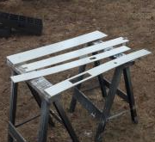

Figure 4.5 Primed Wood

The frame was then assembled back together and all electrical connections were made. The port for the power cable was added to the back of the housing and the power switch was implemented.

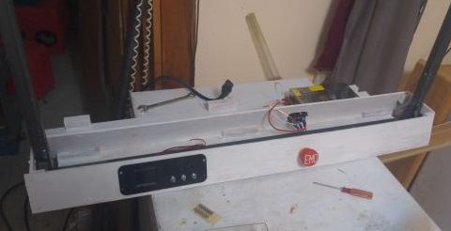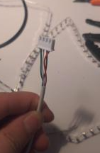

Figure 4.6 Power Cable

The final 3D prints were then created to reduce pinch points, add plastic feet to the bottom of the steel legs, and add labeling to the potentiometers that will manipulate the P, I, and D constants.

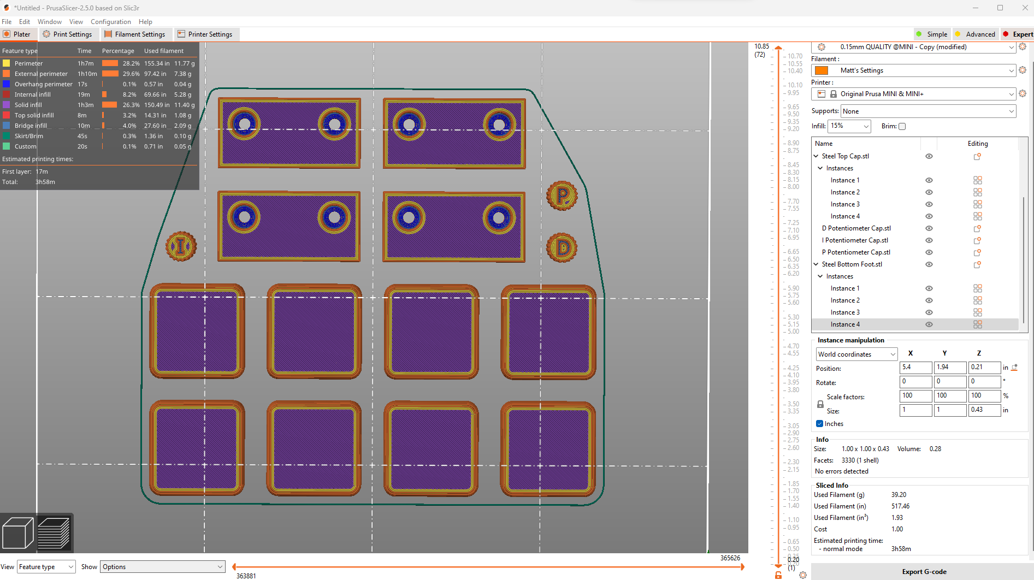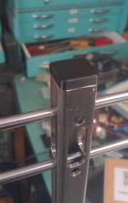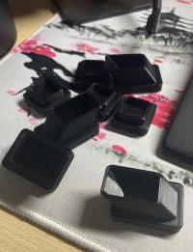

Figure 4.7 3D Printing

Then, Joe 3D printed the encoder mount and attached it to the carriage. An adapter to clamp the pendulum to the encoder was created on the lathe. It uses a set screw and a press fit to hold the pendulum to the encoder.

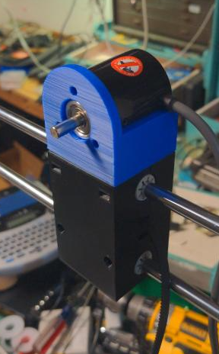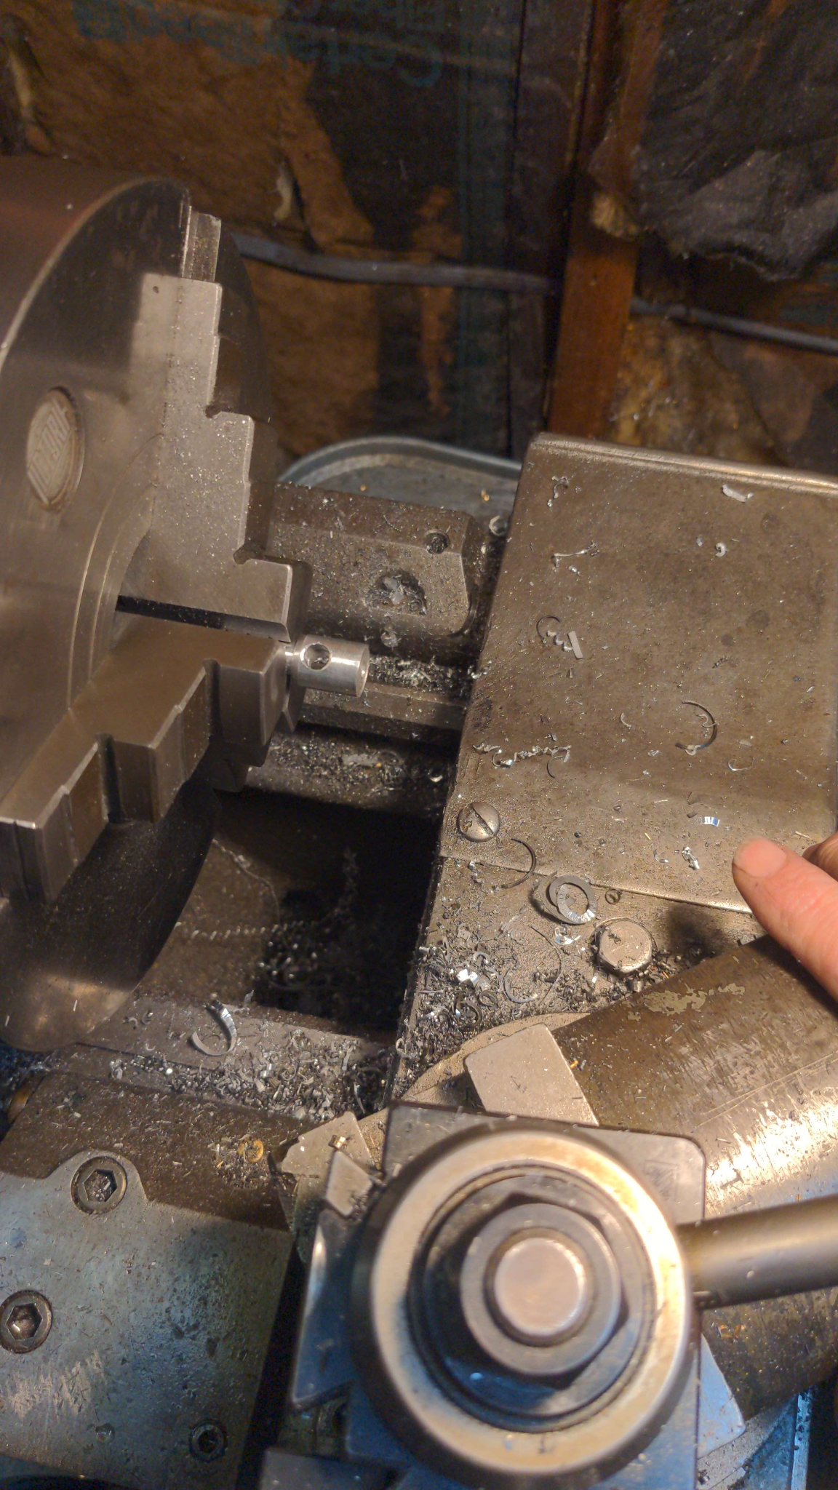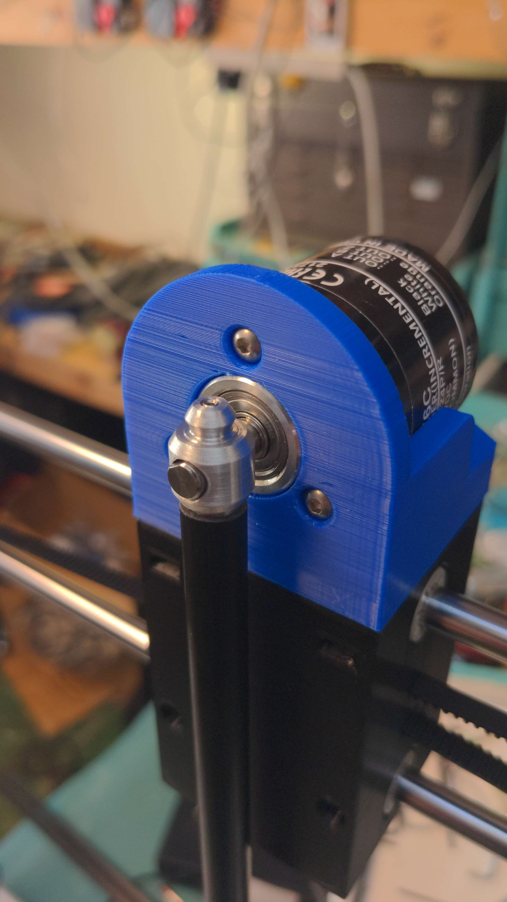

Figure 4.8 Carriage Assembly

The eccentric was then fabricated and the captive belt was secured inside of the carriage. This finished off the carriage manipulator subsystem. All fits were secure and everything was square and parallel. When sliding the carriage back and force along the linear rods, the friction between the carriage and the rods was constant which is a wonderful sign.



Figure 4.9 Belt Tensioner

Finally, the brass end weight was fabricated and secured to the end of the pendulum using a press fit. The endweight was hollowed out to reduce the mass of the pendulum to meet our physical requirement.

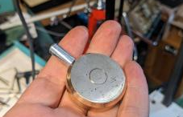

Figure 5.0 Brass Endweight

With this, the entire mechanical system was complete, and the electrical system was complete. The next step was code. However, when Joe went to begin software integration, it was found that the debugger chip was not working. Even after triple checking the connections, the chip still was not working. The problem seemed to lie within the chip attached to the board itself. Luckily, a backup plan had been implemented into the board. A set of connections had been made in which an external debugger could be added onto the board and used when coding.

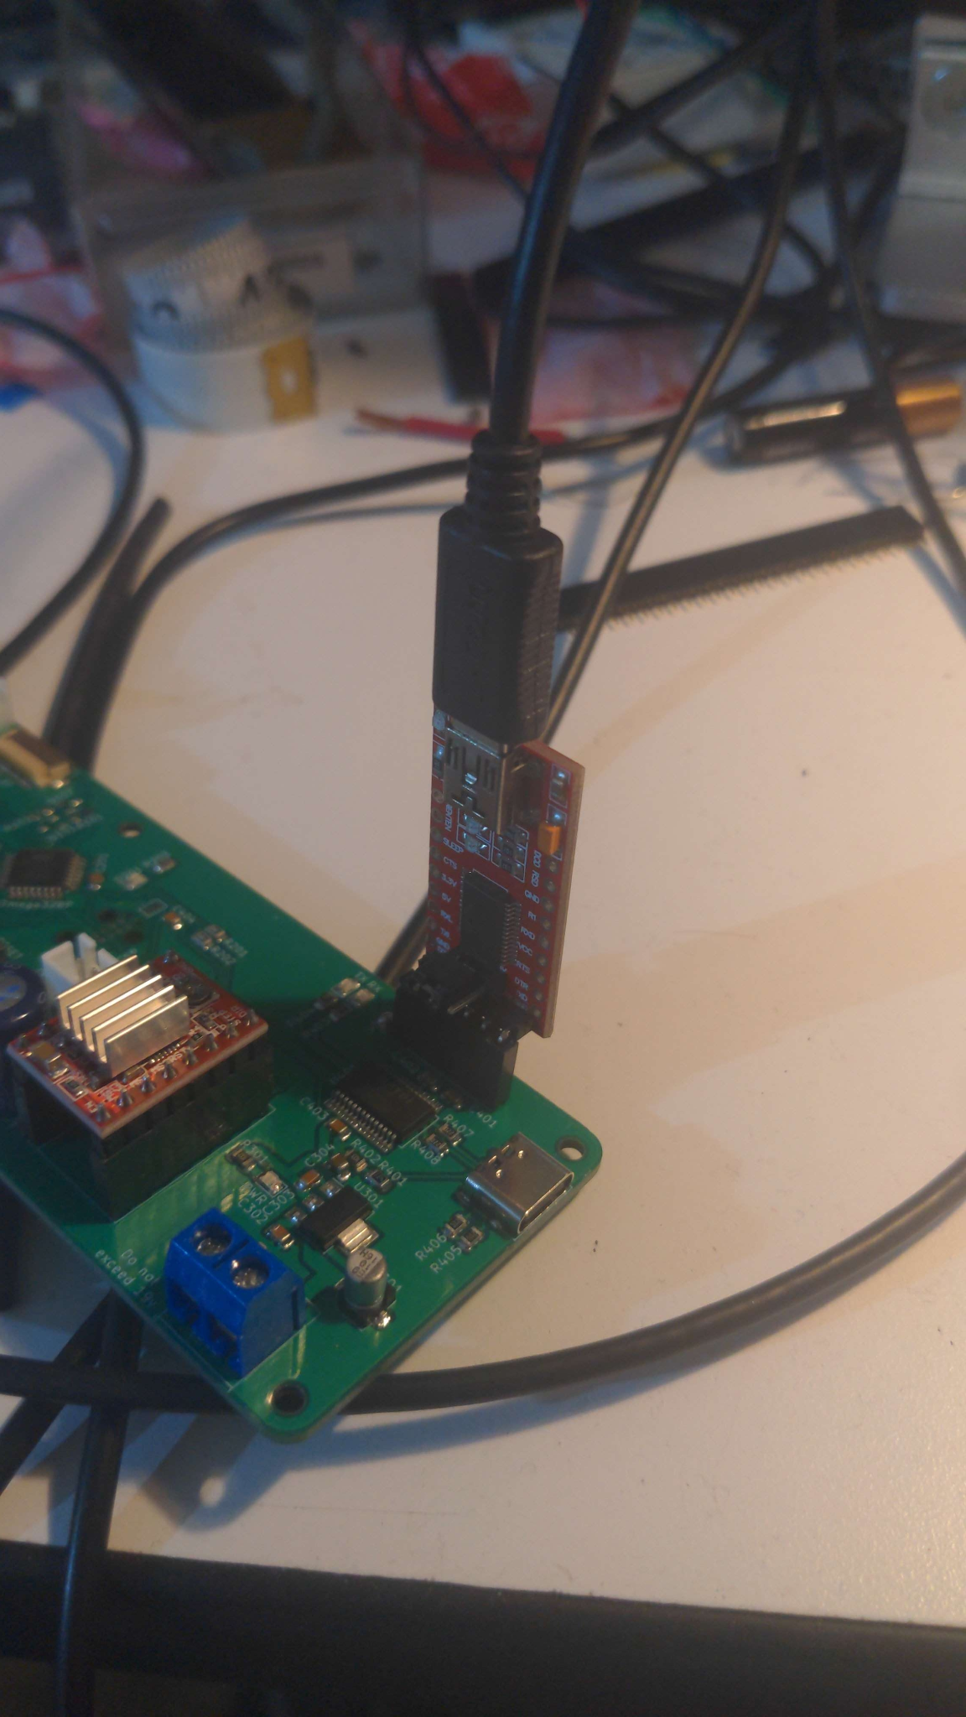

Figure 5.1 External Debugger

The debugger allowed for coding of the system to begin. An issue was also found with the ribbon cable used to connect the TFT screen to the circuit board. While a new one was shipping, a breadboard was used in the meantime to connect the two electrical components. The first goal was to get the system to swing and move. The Drylin bearings seemed to be causing large amounts of friction in the system, and they were replaced with the linear ball bearings. From there, the system had life! The motor was able to easily move the pendulum and the carriage back and forth.

The next goal was to create a code that would zero the encoder so that it knew what encoder count was balanced. Since the pendulum will always hang straight downwards due to gravity, that position would be used as our zero point. If the pendulum was left swinging due to previous operation, the mean between these swings would be found and halved to set as the zero point. Then, the team began coding the PID balancing algorithm. The system only needs a very slight I term and the D term is also quite small. Unfortunately, issues were run into with the motor. As the proportional loop demanded greater and greater speeds the further the pendulum got away from balance, the motor was unable to keep up. The Nema 17 could not handle the steps per second that the system demanded. As a result, the team had to upgrade to the Nema 23 motor that had more torque and a faster maximum angular velocity.

The team also struggled with the initial algorithm for harmonically oscillating into a start position. But, after refining the algorithm and doing some more research, the algorithm was remade from the ground up and has a one hundred percent success rate at inverting the pendulum. Some tuning was able to increase the reliability of balancing the PID loop. Now, the big challenge that the team faces is after swinging up into an inverted state, catching the pendulum using the PID loop has proven to be quite tricky. The team also was unable to finish the user control mode and the mode selection button before the due date of the final presentation. The team plans on implementing this catching feature and the user control mode over the summer even if the class has ended. A mode selection button will not be needed until the user control mode is completed. Besides time constraints, a motor hiccup, and a faulty debugging chip, the project has been relatively bump free, and the team has been extremely successful at producing an impressive PID demonstration tool.

## **Comprehensive Performance Test**

* **Frame Stability** - after welding the frame, apply known forces similar to what the system will experience to test the holding power of the welds

We approximated our total forces to be around 10-15 pounds of force. For testing we placed a 25 pound weight where the force should be applied. The frame showed no deformation after holding the weight for several hours.

* **All soldered connections are secure** - ensure that all pieces soldered are secure and connected to the board

After all of the electrical components were in place in the wooden frame, we shook the box vigorously. After shaking and looking inside of the frame all connections successfully stayed in place.

* **Power** - the system will turn on and off

When the pendulum was moving we switched the power switch to off and the pendulum stopped moving. When we tried to restart the program with the power button in the off state it would not turn on. But when we switched it back to the on state it started to move again.

* **TFT Screen** - values will be provided to the TFT screen and then will be displayed

Values were sent to the TFT screen via software and the TFT screen changed its display according to which values were provided. The TFT screen was able to display these values with a refresh rate of 30hz.

* **Leg Fit** - the legs will fit into the frame and be cut to the same lengths. They will not cause stability problems with the frame

When the legs were stood next to each other, each leg was the same height. The legs were then put into the frame, and our group tried to shake the frame to see if the frame would wobble. After shaking the frame from side to side no wobble was created, meaning it was stable.

* **Belt Tensioning Assembly** - system shall be able to tighten the belt automatically

After the belt was tensioned a ruler was placed to measure the distance between the upper and lower belt to see if the belt was parallel. There was no deviation found meaning the belt was completely parallel concluding our belt had been successfully tightened

* **Electrical internal temps don’t get too high** - the system shall not rise to temperatures that will potentially harm other components when left running too long

The machine was left running for several hours. When then measured to internal temperature and concluded that the internal temperatures were successfully below our max temperature of 90F.

* **Test the self balancing PID** - system shall use a PID loop to balance the pendulum

The pendulum was placed in the upright position and the program was then started. Once we let go of the pendulum, the carriage was able to successfully balance the pendulum in the upright position.

* **Test and ensure harmonic oscillations are working** - system shall allow for the pendulum in a rest position to be swung ip and begin the PID loop

The pendulum was placed in the downright/resting position. Once the program was started the pendulum was able to go from its resting position and successfully swing itself to the PID loop position (upright).

## **Schedule**

Our schedule provides a detailed list of our tasks/assignments that must be completed. Main projects are in **bold**, and subtasks associated with each main project are presented beneath the bold title. Every assignment has a corresponding finish date as well as a starting date. All the projects listed in our schedule are in chronological order. Below are the screenshots of our team schedule:

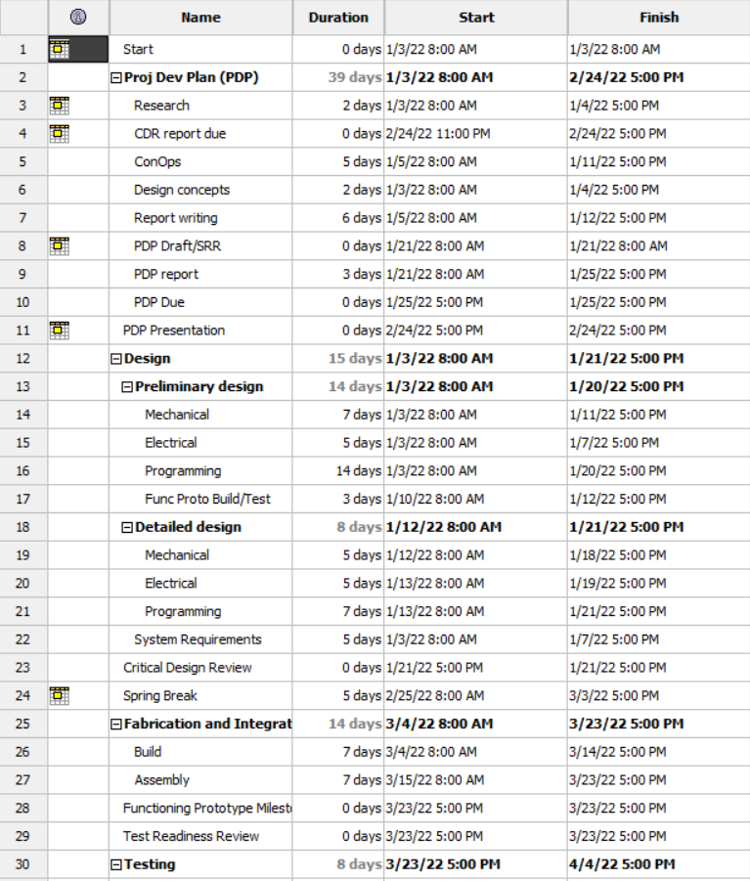

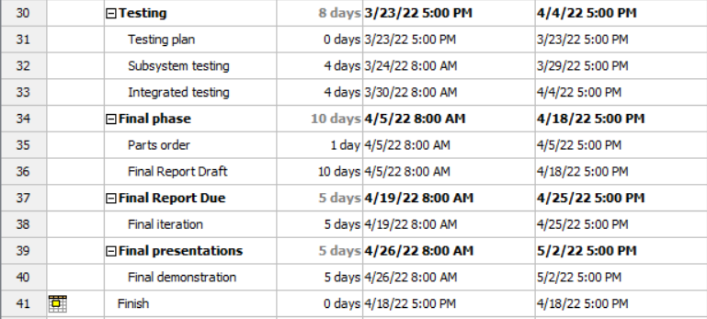

Table 1.6 Project Schedule

## **Project Budget**

After purchasing all needed components for our project, we were able to only spend $189.56 of our $400 project budget. Below is a screenshot of a detailed list containing all the parts purchased as well as their corresponding price. A lot of the components for our circuit board were approximated to be less than a cent, which is why most of the parts listed have a $0.00 price. Some parts were also donated by our team member Joe.

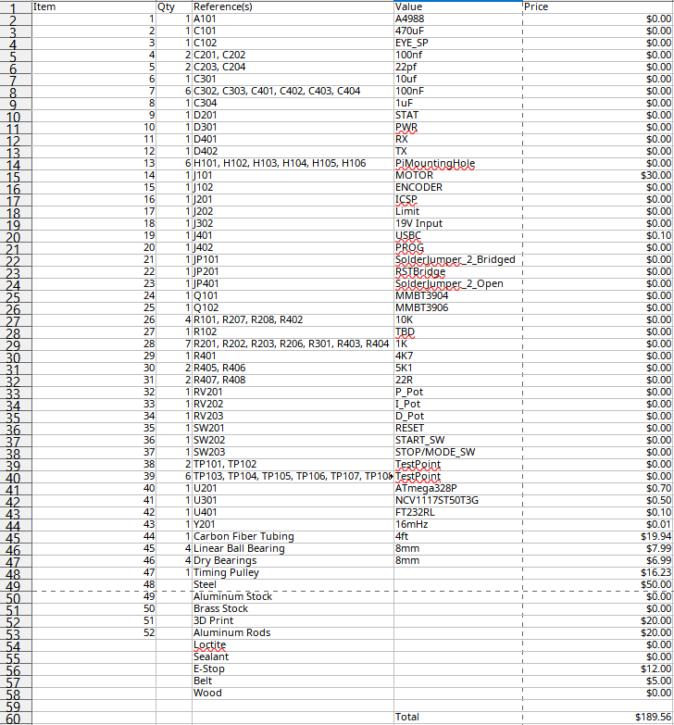

Table 1.7 Project Budget

## **Conclusions and Lessons Learned**

Through the course of creating this project, our group was able to reflect on the things we have done to learn from the mistakes we made as well as things that went well, so we can improve ourselves as engineers and teammates. Below we will reflect in detail about what we have learned through this process.

Stepper motors are not useful for applications that require a variance in speed. In our project one of the key design components was our motor being able to change speeds quickly. In order for our pendulum to be self balancing, the motor had to be able to change directions and acceleration. Though testing we were able to learn that the stepper motor was not a good choice for our project design.

Ordering parts is a huge factor for getting a project completed on time. At the beginning of this project we had several difficulties ordering parts. Because we did not get our parts on time our machining and assembly was delayed which resulted in less time for our group to test. It is crucial for projects that have a time constraint to minimize your time waiting. The earlier you can begin your assembly and testing, the more time you will have to troubleshoot and finalize your product.

Always have a backup plan or a second design option. As found out through our testing phases, everythings does not work according to plan on the first try. Our group first decided on a motor we thought was most appropriate for our design constraints, but soon found out that the motor had too little torque and we needed a bigger motor to meet that criteria. Luckily, we had a backup motor that we could quickly assemble. If we did not have this backup motor, more time would have been wasted on ordering and delivering this part. Which would have resulted in less time for testing.

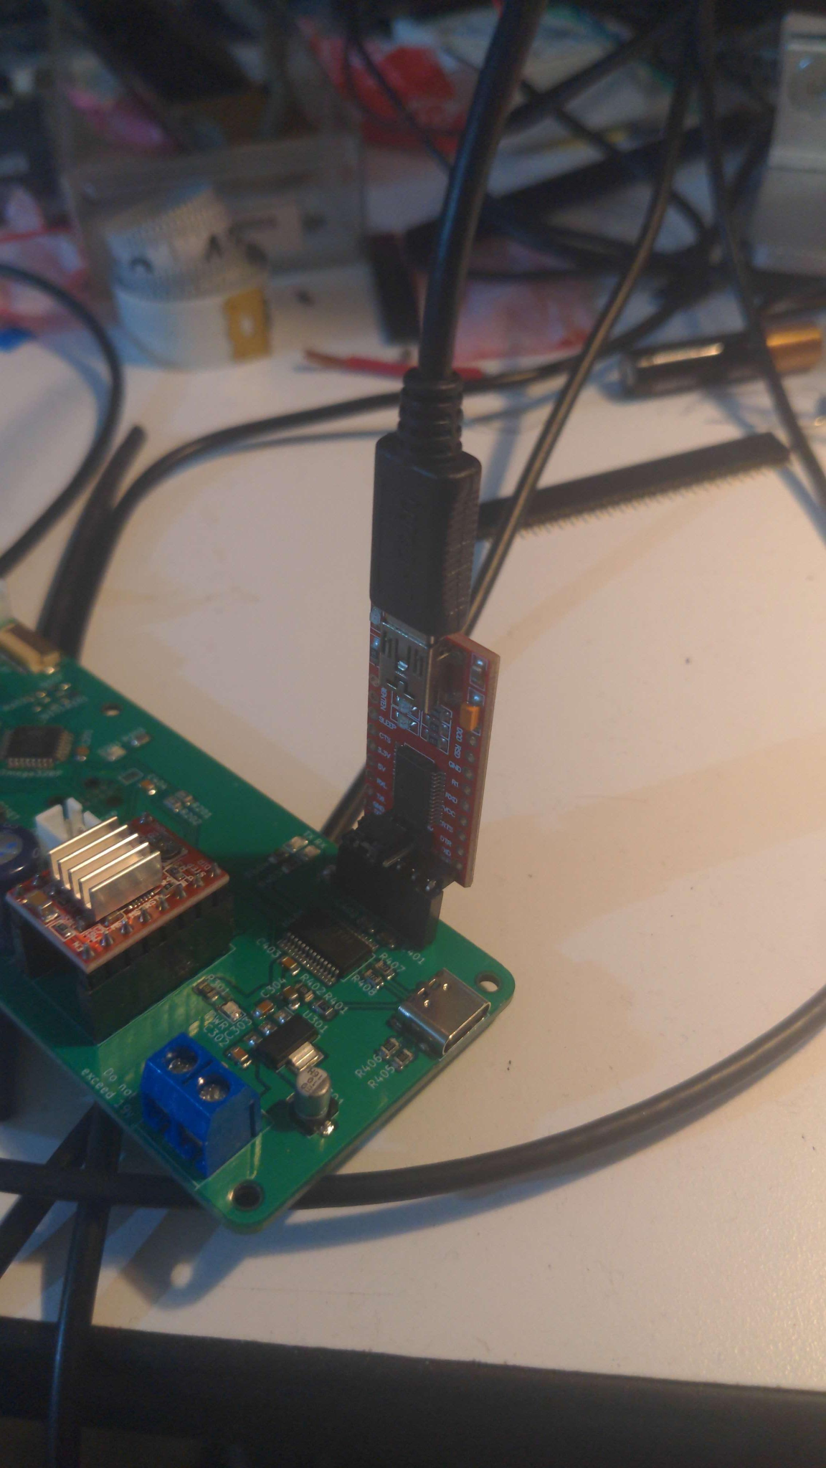

Figure 5.2 Showing the external debugging chip replacing the imbedded debugging chip in the circuit board

Because of our parts being delayed at the beginning of this project, we were not left with as much time as we had intended to troubleshoot and debug. The quicker you can get to the testing stage the better, because you will have more time to perfect your product in case an unexpected issue arises.

Our group was able to work as a team which made us able to work quickly and efficiently. We were able to divide up our total workload evenly which made us a very efficient group. Communication and listening is key to teamwork. Everyone in the group was open to new ideas as well as providing helpful tips and suggestions to each other. Each group member was also very reliable and could be held accountable which made for a successful team.

In the first stages of creating this project we were able to design an idea that was well defined, and realistic. Because our idea was well defined, everyone knew the goal and what we needed to accomplish. And because our idea was realistic, we were able to complete it in the given time constraint.

For this project, our group used a program called git and stored all of our team resources on a service called Github. Git and Github allows you to store files locally and then publish them to a centralized repository that each group member can access. This allowed us to keep all of our files and documents in one place making us very organized. Because we were organized we never had trouble finding a certain document or image. It is crucial to a team's efficiency and success to be well organized so you do not waste time searching, or recreating documents that were lost.

At the beginning of this project each group member wrote down their strengths and weaknesses. This allowed our group to assign tasks to each group member that was most fitting for their strengths. Because of this we were able to work very efficiently. Some tasks will not be anyone's strengths so it is sometimes beneficial to collaborate as a group to overcome your team's weaknesses.

## 

## **References**

Figure (1.0) (n.d.). *Rotary Inverted Pendulum*. Quanser. Retrieved January 22, 2023, from

https://www.quanser.com/wp-content/uploads/2017/03/ROTPEN-graphics.jpg

Figure (1.1) (n.d.). *Lego, Raspberry and Python Project - Reaction Wheel Inverted Pendulum*.

(2022, April 16). YouTube. Retrieved January 22, 2023, from https://youtu.be/WObG2LoSEwQ

## 

## **Appendices**

### **Appendix A. Verification Report**

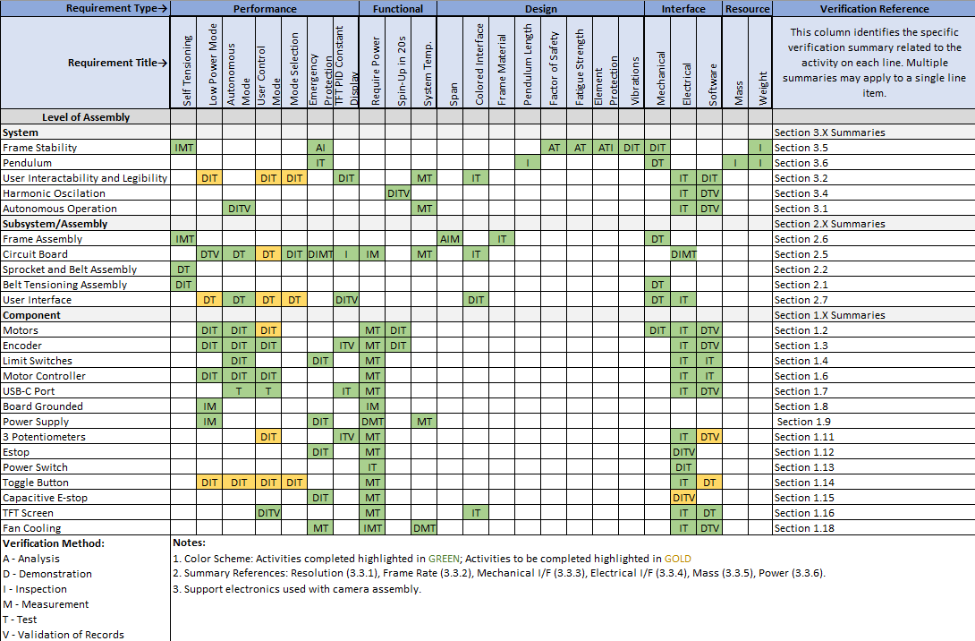

Figure 1.5 Verification Matrix

### **Appendix B. Our “Final” release**

<https://github.com/KenwoodFox/EG-310-InvertedPendulum/releases/tag/v1.3>